**Analysis of Customer Satisfaction Through Service Quality and Digital Payment in the Hermes Palace Hotel Medan**

**Steven Alfando1, Sri Rezeki2, Desma Erica Maryati Manik3**

Sekolah Tinggi Ilmu Ekonomi Eka Prasetya

Medan, North Sumatra, 20212, Indonesia

Email: stevenalfando891@gmail.com

**ABSTRACT**

This research is motivated by a decrease in customer satisfaction where it can be seen from the level of visitors every year has decreased due to the services provided to consumers being less than satisfactory and payments made can only use cash and debit/credit, resulting in a decrease in customer satisfaction which has an effect on the level of visitors without the hotel realizing it. The purpose of this study aims specifically to analyze Customer Satisfaction through Service Quality and Digital Payment in the Tourism Industry. The method used in this research is a quantitative method using primary data sources. Information will be analyzed by quantitative descriptive analysis obtained using a questionnaire instrument distributed to respondents and this research is measured using a Likert scale to obtain conclusions. The sampling technique used the Accidental Sampling technique. Then the data collected relating to the object is analyzed based on the respondents' responses obtained using the Slovin formula. Three hypotheses in this study were formulated and tested using multiple linear regression analysis. The results show that service quality and digital payment have a significant influence on customer satisfaction.

**Keywords:** Customer Satisfaction, Decreased Visitor Levels, Digital Payment, Hotel, Service Quality

**INTRODUCTION**

Regional economic development and business transformation in the current digital era in the tourism industry, especially hospitality, is one of the fields that shows rapid economic growth and development. Tourism as an industry that contributes significantly to the country's foreign exchange reserves and provides direct employment opportunities to a wide segment of the population and will advance the arts and crafts of a nation to preserve the natural beauty, cultural heritage, and history of the land and to advance the process of national unity and global brotherhood (Thommandru et al., 2023). When Indonesia is free from COVID-19 in 2023, it will be a turning point in the revival of the tourism and economic sectors in Indonesia. Indonesia's economic sector in the tourism industry contributed nearly 4.2% to the country's GDP in 2021 (kominfo.go.id). The government's commitment to the tourism industry has encouraged hotel operators to strive to improve their service quality which is expected to expand and further facilitate the growth of the tourism industry (Kompas.com).

In today's digital era, the lifestyle of consumer behavior in spending money can be seen from the technological development factors that exist in the world, one of which is spending something with digital payments. Digital payments provide services that can be received by consumers to access the services provided and financial transactions. Along with the development of the times now, the types of digital payments are increasingly numerous and diverse. Some types of digital payment systems that are often used for transactions are E-Wallet (Ovo, Gopay, and Shopeepay), Internet Banking, Mobile Banking, and Q-RIS, where the payment system is a type of digital payment model that can be accessed using a cellphone and each type of payment system such as E-Wallet and Mobile Banking already has Q-RIS in it which can make it easier for consumers to make payments.

Hermes Palace Hotel Medan is one of the hotel industries with a 4-star rating in North Sumatra and is also one of the favorite hotels in the city of Medan, with a strategic location in the middle of the business and culinary center. The hotel is known for always providing good service and facilities to consumers and following trends in the digital era now. Customers also expect that a higher classification can provide superior satisfaction through better services and facilities. Based on data from Google Maps Review for Hermes Palace Hotel Medan where one of the customers, Jennifer, said, "The service is not good, not serving well and the payment is still old-fashioned cannot use QRIS." and also customer Wiza, said that " Poor service. Hotels are supposed to sell services. But the service provided is very bad. Security talks to guests as if talking to children. There are still many better hotels around this place". Therefore, based on a survey conducted by the researcher on reviews provided by customers on Google Maps Review with an average review rating of 1 to 4 stars, many customers were dissatisfied with the services provided by hotel staff who were not available for 24 hours and the services provided during the initial welcome were also less friendly. Also experiencing dissatisfaction with the payment system available at Hermes Palace Hotel Medan. Where payments can only use the cash and debit/credit cards system, and these payments are part of the digital payment system and in this hotel are not yet available for other digital payments such as payments via M-banking and Q-RIS. In today's digital era, there is a trend of payments using M-banking and QRIS as a tool for transactions and all business sectors have used these payments which are the latest payment methods. This can cause customer dissatisfaction which results in a decrease in visitors at Hermes Palace Hotel Medan.

In 2018 the total visitors were 33,890 people and every year there is a decrease in visitors at the Hermes Palace Hotel Medan. One of the causes is the payment system that can only be done with cash or debit/credit payments and customer dissatisfaction with the services provided by Hermes Palace Hotel Medan. The purpose of this study is to increase customer satisfaction with Hermes Palace Hotel Medan. This problem underlies the research to analyze customer satisfaction through service quality and digital payment in the Hermes Palace Hotel Medan.

**LITERATURE REVIEW**

**Service Quality**

Service quality is the degree of difference between customers' expectations for services and their perceptions of actual performance and an overall evaluation of a particular service, comparing performance to customers' general expectations of what performance should be (Parasuraman et al., 1985). Guests often focus on the importance of hotel staff interactions to describe their feelings and expectations about service quality. Guests often use words such as recognition, friendliness, consideration and attention to describe desired employee interactions (Lu et al., 2015). Aspects such as ambience consisting of lighting, music, noise, temperature (Bonn et al., 2007), and cleanliness are the first and important accommodation in service for the hospitality sector (Wu & Ko, 2013). According to Hu et al. (2009), the indicators below are the evaluation of consumers on Service Quality, which is: (1) Tangibility; (2) Reliability; (3) Responsiveness; (4) Assurance; (5) Empathy

**Digital Payment**

In general, digital or electronic payments refer to transactions made over the Internet, although there are many other forms of electronic payments (Junadi & Sfenrianto, 2015). The main components that have a significant impact in determining customer satisfaction and experience, especially using digital payments (Agarwal et al., 2023). In digital payments, money is stored, processed, and received in the form of digital information and the transfer process is initialized through an electronic payment instrument. Traditional payments are made through cash, checks, or credit cards while digital payments are made using certain software, payment cards, and electronic money. According to Oliveira et al. (2016), shows that information related to perceived technology compatibility and security has a significant direct impact on perceived user behavioral control. Digital payment systems have significantly influenced people to use digital payments, and bring extra convenience to consumers by offering the flexibility of adding payments and accelerating exchanges (Singh Shamshe & Rana Ravish, 2017). Digital payment systems make the payment process easy and convenient in the midst of busy and daily activities, this is important because the use of digital innovation can be applied to minimize physical contact between retailers and consumers (Chaveesuk et al., 2021). Several indicators that can measure digital payments according to Tella & Olasina (2014), which is: (1) Perceived usefulness; (2) Perceived ease of use; (3) Perceived speed; (4) Perceived benefits

**Customer Satisfaction**

Customer satisfaction is a measure of the difference between expectations before buying services/products and the evaluation of consumers after consumption (Oliver, 1980). Satisfaction and dissatisfaction are a comparison between expectations and results. Consumers will be satisfied if the results match expectations (Galabo, 2019). After using a product, consumers will compare the quality and performance against the expectations that consumers want. In addition, there are several aspects that can create self-satisfaction from consumers where frontline service providers in hotels, cleanliness of hotel rooms, quality of service and knowledge, and service of employees are some of the important factors determining the satisfaction of hotel guests. Some of the indicators below can measure Customer Satisfaction according to Naini et al. (2022), which is: (1) Satisfaction; (2) Attitude; (3) Life style; (4) Easy to get.

**Figure 1.** Theoretical Framework

Service Quality

H1

Customer Satisfaction

H3

H2

Digital Payment

Based on the above Framework, the hypothesis of this study is:

H1 : Service Quality Affects Customer Satisfaction

H2 : Digital Payment Affects Customer Satisfaction

H3 : Service Quality and Digital Payment Affects Customer Satisfaction

**RESEARCH METHOD**

This research was conducted at Hermes Palace Hotel Medan by distributing questionnaires to customers who will check out at this hotel. In this study, there are three variables where each variable is measured by several indicators. The data collected uses the Quantitative analysis method. According to Sugiyono (2019:16), the Quantitative analysis method is a scientific method whose research data is in the form of numbers and the analysis uses statistics. The population in this study is based on 2022 visitor data at Hermes Palace Hotel Medan amounting to 9,378 people. It can be seen that the sampling technique used in this study is the Accidental Sampling. Accidental Sampling is a sampling technique based on chance, where anyone who meets can be used as a sample and people who happen to be met must be suitable as a data source (Sugiyono, 2019:133). According to Sugiyono (2019:137), in determining the sample, you can use the Slovin Formula to determine the sample size as follows:

n = $\frac{\text{N}}{\text{1 + N (}{\text{e)}}^{\text{2}}}$

where:

n : Number of samples required  
N : Total Population  
e : Sample error rate (10%)

This study uses a 90% reliability level because it uses an inaccuracy of 10%. If the calculation is done by formula, the minimum number obtained is:

n = $\frac{\text{9.738}}{\text{1 + 9.738 (}{\text{10\%)}}^{\text{2}}}$

n = $\frac{\text{9.738}}{\text{1 + 9.738 (0,01)}}$

n = $\frac{\text{9.738}}{\text{1 + 97,38}}$

n = $\frac{\text{9.738}}{\text{98,38}}$

n = 98,98 or 99 respondents

In this study using a survey method by distributing questionnaires as a research instrument to collect primary data and the questionnaire contains statements related to research variables with a Likert measurement scale with a scale of 1-5, where a value of 1 indicates the lowest value and 5 indicates the highest value. The Likert scale is used to measure the attitudes, opinions, and perceptions of a person or group about social phenomena. (Sugiyono, 2019:146)

**Table 1**. Likert scale

|  |  |
| --- | --- |
| **Value** | **Criteria** |
| 1 | Strongly Disagree (SD) |
| 2 | Disagree (D) |
| 3 | Disagreement (DS) |
| 4 | Agree (A) |
| 5 | Strongly Agree (SA) |

The data processing process is carried out by testing multiple linear regression analysis where linear regression analysis is related to the study of the dependence of the dependent variable on the independent variable, the aim is to estimate and predict the population average or average value of the dependent variable based on known independent values. Multiple linear analysis is used to analyze Customer Satisfaction through Service Quality and Digital Payment. The calculation can be formulated with the following formula:

Y= a + b1 X1 + b2 X2 + e

where:

Y : Customer Satisfaction  
X1  : Service Quality  
X2 : Digital Payment  
a : Constant  
b1  : Coefficient for Service Quality variable  
b2  : Coefficient for Digital Payment variable  
e : Standard Error (5%)

The techniques used to analyze the data are Validity Test, Reliability Test, Normality Test, Descriptive Statistics, Multicollinearity Test, Partial Significance Test and Simultaneous Significance Test.

**RESULT**

**Validity dan Reliability**

The following is the results of the validity and reliability tests of 31 statements consisting of 15 Service Quality Statements, 8 Digital Payment Statements, and 8 Consumer Satisfaction Statements. The analysis results show that the validity coefficient ranges from 0.374 to 0.869, while the r table value with a significance level of 0.05 for a sample of 30 respondents is 0.361. The validity test results show that all statement points on variables Service Quality, Digital Payment, and Customer Satisfaction have r count > 0.361, so the data on all variable items are declared valid. The results of the reliability test using Cronbach's Alpha show that each variable is obtained > 0.60, so the data can be declared reliable.

**Table 2.** Kolmogorov-Smirnov Normality Test Results

|  |  |
| --- | --- |
|  | Unstandardized Residual |
| N | 99 |
| Asymp. Sig. (2-tailed) | 0,200 |

Based on the data above, it can be seen that the results of the Kolmogorov-Smirnov normality test prove that the resulting significance value is greater than 0.05, which is 0.200. So, it can be concluded that the data is declared normally distributed.

**Figure 2**. Histogram Normality Test Results

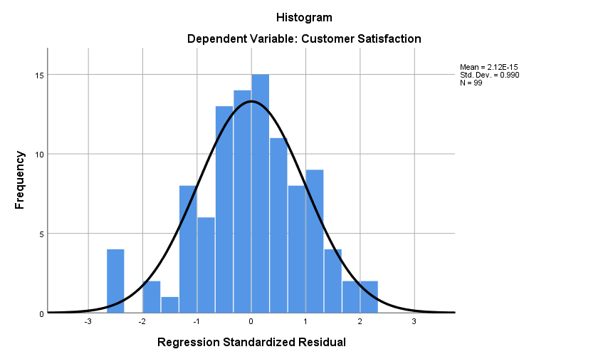

In the picture above is a histogram graph where it can be said to be normal if the data distribution forms a bell (bell-shaped), and does not lean to the right or left, so the histogram graph is declared normal.

**Figure 3.** Probability Plot Normality Test Results

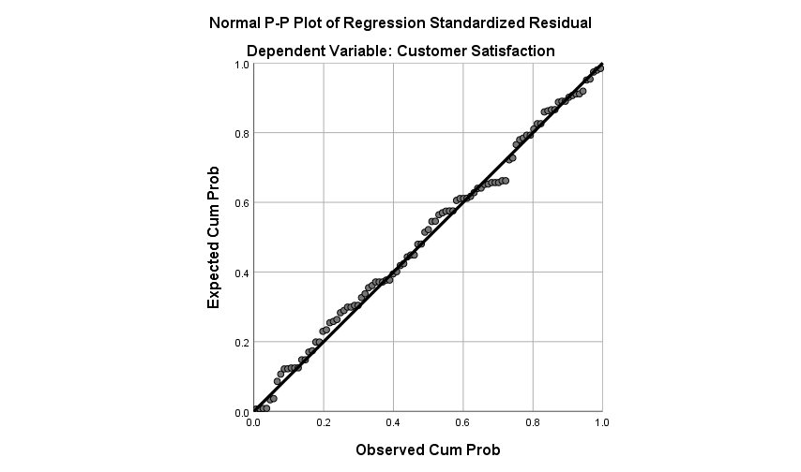

In the picture above, it can be seen that the dots (data) are close to the diagonal line, so it can be concluded that the data is normally distributed and fulfills the assumptions of normality testing.

**Table 3.** Descriptive Statistics

|  |  |  |  |  |  |
| --- | --- | --- | --- | --- | --- |
| Variable | N | Min | Max | Mean | Std. Deviation |
| Service Quality | 99 | 41 | 69 | 53,79 | 6,231 |
| Digital Payment | 99 | 23 | 37 | 29,15 | 3,477 |
| Customer Satisfaction | 99 | 24 | 37 | 29,61 | 3,067 |

Descriptive statistical analysis is used to describe and assess the data characteristics of each research variable. The results of the analysis show that the amount of data used in this study were 99 respondents from consumers of Hermes Hotel Palace Medan. The Service Quality variable has an average value of 53.79 with a data distribution level of 6.231. The Digital Payment variable has an average value of 29.15 with a data distribution level of 3.477. The Customer Satisfaction variable has an average value of 29.61 with a data distribution level of 3.067.

**Table 4.** Multicollinearity Test

|  |  |  |
| --- | --- | --- |
| Variable | Tolerance | VIF |
| Service Quality (X1)  Digital Payment (X2) | 0,233  0,233 | 4,289  4,289 |

Based on the data above, the VIF value obtained is 4.289 < 10 and the Tolerance value is 0.233 > 0.1, it can be concluded that the independent variables Service Quality and Digital Payment do not have multicollinearity.

**Multiple Linear Regression Analysis  
Table 5.** Multiple Linear Regression Analysis Test Results

|  |  |  |  |  |  |  |
| --- | --- | --- | --- | --- | --- | --- |
| Coefficients | | | | | | |
| Model | | Unstandardized Coefficients | | Standardized Coefficients | t | Sig. |
| B | Std. Error | Beta |
| 1 | (Constant) | 5,515 | 1,248 |  | 4,420 | 0,000 |
|  | Service Quality | 0,297 | 0,047 | 0,604 | 6,350 | 0,000 |
|  | Digital Payment | 0,278 | 0,084 | 0,315 | 3,310 | 0,001 |
| 1. Dependent Variable: Customer Satisfaction | | | | | | |

In this study, the classical assumption test has been met. Multiple linear regression analysis was processed using the SPSS version 26 application, with the following regression equation:

**Customer Satisfaction = 5.515 + 0.297 Service Quality + 0.278 Digital Payment + e**

The positive constant value of 5.515 indicates that there is a positive influence of the independent variable. If the independent variable increases or has an effect of one unit, the Customer Satisfaction variable will increase or be fulfilled. The Regression Coefficient of the Service Quality and Digital Payment variables of 0.297 and 0.278 respectively indicates that if the Service Quality and Digital Payment variables increase or have an effect of 1 unit in a positive direction, then Service Quality and Digital Payment will increase by 0.297 and 0.278 units respectively and can have a positive effect or increase in the same direction. This means that increasing Service Quality and using Digital Payment affects Customer Satisfaction at Hermes Palace Hotel Medan.

**Hypothesis Test**

**Partial Test**

The ttable value for 99 respondents with a significance value of 0.05 and a two-way test of 1.984. The analysis results show that the Service Quality variable has a tcount of 6.350 > ttable 1.984 with a significance value of 0.000 < 0.05, it can be concluded that Service Quality has a partially significant effect on Customer Satisfaction at Hermes Palace Hotel Medan. The Digital Payment variable has a tcount of 3.310 > ttable 1.984 with a significance value of 0.001 < 0.05, it can be concluded that Digital Payment has a partially significant effect on Customer Satisfaction at Hermes Palace Hotel Medan.

**Simultaneous Test  
Table 6.** Simultaneous Test Results

|  |  |  |
| --- | --- | --- |
| Model | F | Sig. |
| 1 Regression  Residual  Total | 188,936 | 0,000 |

The Ftable value for 99 respondents with a significance value of 0.05 is 3.09. The analysis results show that the Fcount value of 188.936 > Ftable value of 3.09 with a significance value of 0.000 < 0.05, it can be concluded that Service Quality and Digital Payment simultaneously have a significant effect on Customer Satisfaction at Hermes Palace Hotel Medan.

**Coefficient of Determination**

**Table 7.** Test Coefficient of Determination

|  |  |  |  |  |
| --- | --- | --- | --- | --- |
| Model | R | R Square (R2) | Adjusted R Squared | Std. Error of the Estimate |
| 1 | 0,893 | 0,797 | 0,793 | 1,395 |

The coefficient of determination (R2) test results shows a figure of 0.797 or 79.7%. These results indicate that the Service Quality and Digital Payment variables at Hermes Palace Hotel Medan are able to explain the variation in the Customer Satisfaction variable by 79.7%, while the remaining 20.3% is explained by other variables not used in this research model.

**DISCUSSION**

**Analysis of Customer Satisfaction Through Service Quality**

Based on the results of the research that has been done, it was obtained that H1 was accepted which it shows that the Service Quality variable has a regression coefficient of 0.297 and partial hypothesis testing (t test) has a tcount value of 6.350 > ttable 1.984 with a significance value of 0.000 < 0.05 which shows a positive direction, which means that partially the Service Quality variable has a direct influence on increasing Customer Satisfaction at Hermes Palace Hotel Medan. This is in accordance with the results of research conducted by Lu et al. (2015) who found that service quality can increase customer satisfaction by understanding the experiences and needs of consumers including overall hotel services that can make to minimize negative experiences and maximize positive experiences.

**Analysis of Customer Satisfaction Through Digital Payment**

Based on the results of the research that has been done, it was obtained that H2 was accepted which it shows that the Digital Payment variable has a regression coefficient of 0.278 and partial hypothesis testing (t test) has a tcount value of 3.310 > ttable 1.984 with a significance value of 0.001 < 0.05 which shows a positive direction, which means that partially the Digital Payment variable has a direct influence on increasing Customer Satisfaction at Hermes Palace Hotel Medan. This is in accordance with the results of research conducted by Agarwal et al. (2023) which found that digital payments can increase customer satisfaction and experience in providing additional insight and knowledge and also make the customers more comfortable.

**Analysis of Customer Satisfaction Through Service Quality and Digital**

Based on the results of the research that has been done, it was obtained that H3 was accepted which it shows that the Fcount value is 188.936 > Ftable 3.09 with a significance value of 0.000 < 0.05, which means that there is a significant influence between improving Service Quality and Using Digital Payment as a transaction tool simultaneously on Customer Satisfaction which can also increase the level of visitors who come to Hermes Palace Hotel Medan. This is in accordance with the results of research conducted by Ajina et al. (2023) who found that by improving high service quality and using digital payments which can facilitate and save time in the payment process which can increase customer satisfaction.

In the coefficient of determination (R2) test, it was obtained at 0.797, meaning that the Customer Satisfaction variable can be explained by the Service Quality and Digital Payment variables by 79.7%, while the remaining 20.3% was influenced by other variables not used in this research model.

**CONCLUSION**

Based on the results of the research conducted, it can be concluded that by improving Service Quality and making transactions using Digital Payment can have a significant effect on Hermes Palace Hotel Medan. Hotels known by the public are as service providers, services and also provide adequate facilities for consumers, but at this hotel many customers are dissatisfied with the services provided by hotel staff, one of which is hotel staff who are not available for 24 hours in providing services and provide an initial greeting that is less friendly. which makes the first view for customers about the hotel bad. In addition, in today's era there are many people who use digital payment as a tool for transactions, but at this hotel can only use cash and debit/credit as a means of payment. Although there are some people who are less adept at using technology, from the results of the research conducted it can be concluded that if payments are made digitally, it will make customers feel easier to transact with large amounts of money and also get additional promos or discounts that can be obtained by consumers when using digital payments. Therefore, by improving Service Quality and using Digital Payment as a tool for transactions will be able to increase Customer Satisfaction and can also increase the level of visitors at Hermes Palace Hotel Medan.

**REFERENCES**

Agarwal, S., Malik, P., & Gautam, S. (2023). Analysis of Customer Satisfaction and the Customer Experience in Digital Payments: A Meta-Analysis Review. *International Journal of Business Science and Applied Management*, *18*(1).

Ajina, A. S., Joudeh, J. M. M., Ali, N. N., Zamil, A. M., & Hashem, T. N. (2023). The effect of mobile-wallet service dimensions on customer satisfaction and loyalty: An empirical study. *Cogent Business and Management*, *10*(2). https://doi.org/10.1080/23311975.2023.2229544

Bonn, M. A., Joseph-Mathews, S. M., Dai, M., Hayes, S., & Cave, J. (2007). Heritage/cultural attraction atmospherics: Creating the right environment for the heritage/cultural visitor. *Journal of Travel Research*, *45*(3). https://doi.org/10.1177/0047287506295947

Chaveesuk, S., Khalid, B., & Chaiyasoonthorn, W. (2021). Digital payment system innovations: A marketing perspective on intention and actual use in the retail sector. *Innovative Marketing*, *17*(3). https://doi.org/10.21511/im.17(3).2021.09

Galabo, N. R. (2019). Canteen service quality and student satisfaction. *International Journal of Scientific and Technology Research*, *8*(6).

Hu, H. H., Kandampully, J., & Juwaheer, D. D. (2009). Relationships and impacts of service quality, perceived value, customer satisfaction, and image: An empirical study. *Service Industries Journal*, *29*(2). https://doi.org/10.1080/02642060802292932

Junadi, & Sfenrianto. (2015). A Model of Factors Influencing Consumer’s Intention to Use E-payment System in Indonesia. *Procedia Computer Science*, *59*. https://doi.org/10.1016/j.procs.2015.07.557

Lu, C., Berchoux, C., Marek, M. W., & Chen, B. (2015). Service quality and customer satisfaction: Qualitative research implications for luxury hotels. *International Journal of Culture, Tourism, and Hospitality Research*, *9*(2). https://doi.org/10.1108/IJCTHR-10-2014-0087

Naini, N. F., Sugeng Santoso, Andriani, T. S., Claudia, U. G., & Nurfadillah. (2022). The Effect of Product Quality, Service Quality, Customer Satisfaction on Customer Loyalty. *Journal of Consumer Sciences*, *7*(1). https://doi.org/10.29244/jcs.7.1.34-50

Oliveira, T., Thomas, M., Baptista, G., & Campos, F. (2016). Mobile payment: Understanding the determinants of customer adoption and intention to recommend the technology. *Computers in Human Behavior*, *61*. https://doi.org/10.1016/j.chb.2016.03.030

Oliver, R. L. (1980). A Cognitive Model of the Antecedents and Consequences of Satisfaction Decisions. *Journal of Marketing Research*, *17*(4). https://doi.org/10.1177/002224378001700405

Parasuraman, A., Zeithaml, V. A., & Berry, L. L. (1985). A Conceptual Model of Service Quality and Its Implications for Future Research. *Journal of Marketing*, *49*(4). https://doi.org/10.1177/002224298504900403

Singh Shamshe, & Rana Ravish. (2017). Study of Consumer Perception of Digital Payment Mode. *Journal of Internet Banking and Commerce (JIBC)*, *22*(3).

Tella, A., & Olasina, G. (2014). Predicting Users’ Continuance Intention Toward E-payment System: An extension of thge Technology Acceptance Model. *International Journal of Information Systems and Social Change*, *5*(1).

Thommandru, A., Espinoza-Maguiña, M., Ramirez-Asis, E., Ray, S., Naved, M., & Guzman-Avalos, M. (2023). Role of tourism and hospitality business in economic development. *Materials Today: Proceedings*, *80*. https://doi.org/10.1016/j.matpr.2021.07.059

Wu, H. C., & Ko, Y. J. (2013). Assessment of Service Quality in the Hotel Industry. *Journal of Quality Assurance in Hospitality and Tourism*, *14*(3). https://doi.org/10.1080/1528008X.2013.802557