**The Influence Of Regional Original Income And Economic Growth On Capital Expenditure In Indonesia During The Digital Era**

**Harini Vita Puteri1, Putri Wahyuni2, Frenky Situmorang3**

Sekolah Tinggi Ilmu Ekonomi Eka Prasetya Medan

Jl. Merapi No.08, Pusat Ps., Kec. Medan Kota, Kota Medan, Sumatera Utara, 20212, Indonesia

[harinivitaputeriii@gmail.com](mailto:tiarazhu@icloud.com)

**ABSTRACT**

The objective of this research’s to understand and analyze Regional Original Income and Economic Growth significantly affect the Capital Expenditure in Indonesia during the Digital Era. This study uses quantitative data methods and the type of data is secondary data. The population of this study includes all 34 provinces in Indonesia as of 2022. The sample in this study uses a saturated sampling technique, which means that is uses the entire population in this study. Data analysis and testing consist of descriptive statistics, classical assumption test, multiple regression analysis, partial hypothesis testing (T-test), simultaneous hypothesis testing (F test), and coefficient of determination test. The results of this study indicate that Regional Original Income has a partially significant effect on Capital Expenditure with a calculated T count of 6,570 > T-table 2,037. Economic Growth has no partial effect on Capital Expenditure with a calculated T count of 0,293 < T-table 2,037. Regional Original Income and Economic Growth simultaneously have a significant effect on Capital Expenditure with a calculated F count of 21,602 > F-table 3,30 and a regression coefficient value of 58,2%.

**Keywords:** capital; economic, expenditure, growth, income, original, regional

**INTRODUCTION**

The digital era has brought many changes in communication, transaction, and information access. The rapid development in the digital era is so fast that it provides various changes in all aspects, one of which is to increase inclusiveness and equity in the economic sector. Capital expenditure is a very important aspect because capital expenditure is on way to develop regional potential and improve welfare and services to the community where capital expenditure is allocated to support financing for infrastructure development activities that can increase economic growth, create employment opportunities, and alleviate poverty.

One of the factors needed to finance capital expenditure is regional original income. Regional original income is the income obtained by regional governments from economic sources in their respective regions. Shifting the composition of expenditure is a logical effort made by regional governments in an effort to increase the level of public trust which can be done by increasing capital investment (Kusnandar & Siswantoro, 2012). It is expected that through regional original income can increase capital expenditure so as to achieve equitable development.

Another factor that can influence capital expenditure is economic growth. Economic growth is an increase in the economic value of a country or region in a certain period. According to (Andaiyani, 2013)regional needs for advice and infrastructure, both for the smooth implementation of government tasks and for public facilities affect the amount of capital expenditure. With high economic growth, it is expected that it can increase capital expenditure so that it can improve the welfare of the community.

**LITERATURE REVIEW**

**Capital Expenditure**

Capital expenditure, also known as capital investment, refers to the spending on long-term assets, such as machinery, equipment, buildings, and infrastructure. These assets are expected to provide benefits over an extended period, contributing to the future productivity and growth of a business or region. According to (*Law No. 25 of 2007*, n.d.), capital expenditure is central government expenditure made in the context of capital formation in the form of land, equipment and machinery, buildings and structures, networks, and other physical forms. Fulfilled capital expenditure will be easier to fulfill and improve welfare and services to the community.

According to the Regulation of the Minister of Finance of the Republic Indonesia No.101/PMK.02/2011, the realization of capital expenditure per period in the form of capital expenditure on land, equipment and machinery, buildings and structures, expenditure on roads, irrigation, and networks, other capital expenditure, and public service agency.

**Figure 1.** Capital Expenditure Growth Graph

*Data Source: Central Agency Statistics*

**Regional Original Income**

Regional Original income refers to the revenue generated by a local government from sources within its jurisdiction. This includes taxes, fees, fines, and profits from government-owned enterprises. Regional Original income is a crucial component of a region's budget, as it helps fund public services, infrastructure development, and other essential expenditures.According to (*Law No. 33 of 2004*, n.d.), Regional Original Income is income obtained by the region which is levied based on local regulations in accordance with statutory regulations. According to Government Regulation No.58 of 2005, the realization of regional original income per period obtained from regional taxes, regional levies, the result of management of separated regional wealth, and other legitimate regional original revenue.

**Figure 2.** Regional Original Income Gowth Graph

*Data Source: Central Agency Statistics*

**Economic Growth**

Economic growth refers to the increase in the production of goods and services in an economy over a period of time. It is typically measured as the percentage change in a country's gross domestic product (GDP) from quarter to quarter or year to year. A growing economy means that people are generally producing more goods and services and therefore have more money to spend. This can lead to higher wages, better living standards, and more opportunities for investment and job creation.

According to (Ansofino et al., 2020), Economic Growth is an increase in GDP / GNP regardless of whether the increase is greater or smaller than population growth or whether there is a change in economic structure or not. According to (Ansofino et al., 2020), the formula for calculating the rate of economic growth is as follows:

R(t-1t) = GDPt - GDPt-1 x 100%

GDPt-1

**Figure 3.** Economic Growth Graph

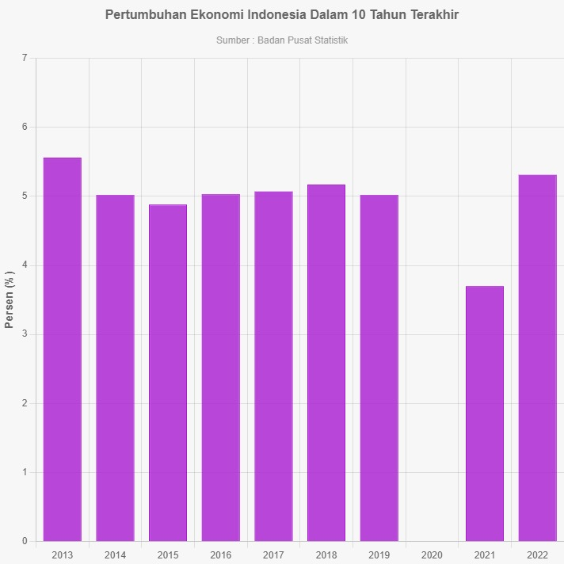

*Data Source: Central Agency Statistics*

Based on the above description and previous research results, the variables in this study can be seen in the research framework diagram:

**Figure 4.** Framework

Regional Original Income

Economic Growth

Capital Expenditure

(Y)

H1

H3

H2

The hypotheses in this study are:

H1 : Regional Original Income has a significant influence on Capital Expenditure in

Indonesia During the Digital Era of 2022.

H2 : Economic Growth has a significant influence on Capital Expenditure in

Indonesia During the Digital Era of 2022.

H3 : Regional Original Income and Economic Growth have a significant influence

on Capital Expenditure in Indonesia During the Digital Era of 2022.

**RESEARCH METHOD**

This study was conducted by accessing the websites of the Ministry of Finance of the Republic of Indonesia [www.kemenkeu.go.id](http://www.kemenkeu.go.id) and the Central Bureau of Statistics [www.bps.go.id](http://www.bps.go.id) and downloading reports on regional original income, capital expenditure, and gross regional domestic product of Indonesia available on those sites. This research was conducted from June 1st to September 30th, 2023.

The study employed a quantitative approach and secondary data. The population in this study consists of the 34 provinces in Indonesia. According to (Sugiyono, 2017), the population is a generalization area consisting of objects/subjects with specific quantities and characteristics determined by the researcher for the study and subsequent conclusions. The sample is a portion of the quantity and characteristics possessed by the population. The sample selection technique in this study used a Saturated Sample, which includes all 34 provinces in Indonesia.

Data analysis and testing consisted of:

1. Descriptive Statistics
2. Classic Assumption Tests
3. Normality Test
4. Heteroscedasticity Test
5. Multicollinearity Test
6. Autocorrelation Test
7. Multiple Linear Regression Analysis
8. Hypothesis Testing
9. T Test
10. F Test
11. Coefficient of Determination Test

**RESULTS**

**Descriptive Statistics**

According to (Ghozali, 2018), descriptive statistics provide a description or overview of data based on mean, variance, maximum, minimum, standard deviation, range, sum, kurtosis, and skewness (distribution skewness).

**Table 1.** Descriptive Statistics Test Results

|  |  |  |  |  |  |
| --- | --- | --- | --- | --- | --- |
| Variable | N | Min. | Max. | Mean | Std. Deviation |
| Regional Original Income (X1) | 34 | 900.34 | 54915.27 | 9456.0176 | 13655.58399 |
| Economic Growth (X2) | 34 | 2,01 | 22,94 | 5,7556 | 3,70352 |
| Capital Expenditure (Y) | 34 | 1340.51 | 18401.32 | 5404.2944 | 3952.27614 |

*Data Source: Data Processing Results, 2023.*

The analysis results show that the total data used is 34, which is the number of provinces in Indonesia. The Regional Original Income variable (X1) with a minimum value of 900.34 and a maximum value of 54915.27 has an average of 9456.0176 and a data dispersion rate of 13655.58399. The Economic Growth variable (X2) with a minimum value of 2,01 and a maximum value of 22,94 has an average of 5,7556 and a data dispersion rate of 3,70352. The Capital Expenditure variable (Y) with a minimum value of 1340.51 and a maximum value of 18401.32 has an average of 5404.2944 and a data dispersion rate of 3952.27614.

**Normality Test**

According to (Sujarwaeni, 2015), the normality test is used to determine whether, in a regression model, both the dependent and independent variables have a normal distribution or not. Normality testing can be done using the one-way Kolmogorov-Smirnov test, with the testing criteria being if the significance > 0,05, then the variable has a normal distribution, and vice versa if the significance < 0,05, then the variable does not have a normal distribution.

The following are the normality test results before transformation:

**Figure 5**. Normality Test Results of Histogram Graph before transformation

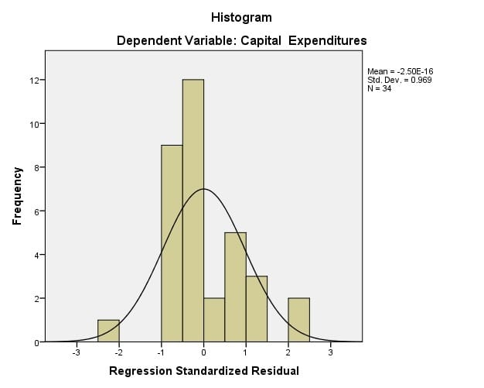

*Data Source: Data Processing Results, 2023.*

Based on the above figure, the histogram graph shows that the data forms a curve line that is not symmetrical to the mean (U). The test results indicate that the data is not normally distributed.

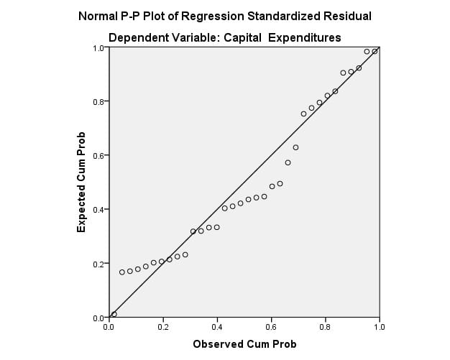**Figure 6**. P-Plots Normality Test Results Before Transformation

*Data Source: Data Processing Results, 2023.*

Based on the above figure, the normal probability plots show that the data points do not spread close to or follow the diagonal line. The test results indicate that the data is not normally distributed.

**Table 2.** Normality Test (Kolmogorov-Smirnov) Results before transformation

|  |  |
| --- | --- |
|  | Unstandardized Residual |
| N | 34 |
| Normal Parametersa,b Mean | 0.0000000 |
| Std. Deviation | 2318.38726192 |
| Most Extreme Absolute | 0.153 |
| Differences Positive | 0.153 |
| Negative | -0.130 |
| Test Statistic | 0.153 |
| Asymp. Sig (2-tailed) | 0,042c |

*Data Source: Data Processing Results, 2023.*

Based on the normality test results with the Kolmogorov-Smirnov test, the Asymp. Sig (2-tailed) value is 0,042. It can be concluded that the regression equation model is not normally distributed because the Asymp. Sig (2-tailed) value is smaller than the alpha value of 0,05.

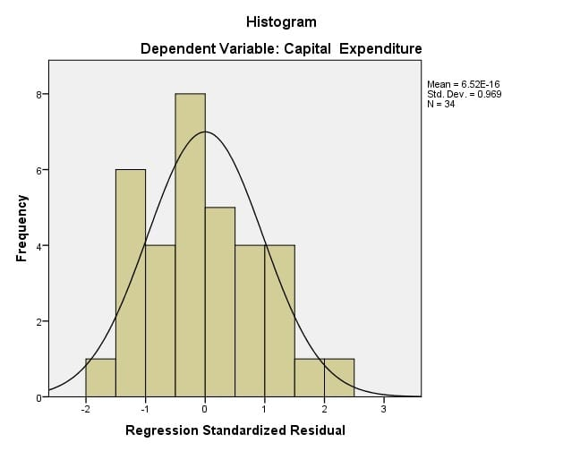**Figure 7.** Normality Test Results of Histogram Graph after transformation

*Data Source: Data Processing Results, 2023.*

Based on the above figure, it can be explained that the data forms a curve line that tends to be symmetrical to the mean (U). The test results indicate that the data is normally distributed**.**

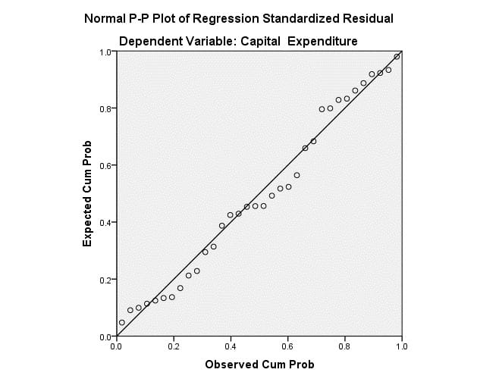**Figure 8.** P-Plots Normality Test Results after transformation

*Data Source: Data Processing Results, 2023.*

Based on the above figure, it can be explained that the data points spread following the diagonal line. The test results indicate that the data is normally distributed**.**

**Table 3.** Normality Test (Kolmogorov-Smirnov) Results after transformation

|  |  |
| --- | --- |
|  | Unstandardized Residual |
| N | 34 |
| Normal Parametersa,b Mean | 0.0000000 |
| Std. Deviation | 15.85201301 |
| Most Extreme Absolute | 0.097 |
| Differences Positive | 0.093 |
| Negative | -0.097 |
| Test Statistic | 0.097 |
| Asymp. Sig (2-tailed) | 0,200 c |

*Data Source: Data Processing Results, 2023.*

Based on the normality test results with the Kolmogorov-Smirnov test, the Asymp. Sig (2-tailed) value is 0,200. It can be concluded that the regression equation model is normally distributed because of the Asymp. Sig (2-tailed) value is greater than the alpha value of 0,05.

**Heteroscedasticity Test**

According to (Ghozali, 2018), the heteroskedasticity test aims to examine whether there is an inequality in the variance of residuals between one observation and another in a regression model. Heteroskedasticity testing can be done by looking at Scatterplots.

**Figure 9**. Heteroscedasticity Test Results

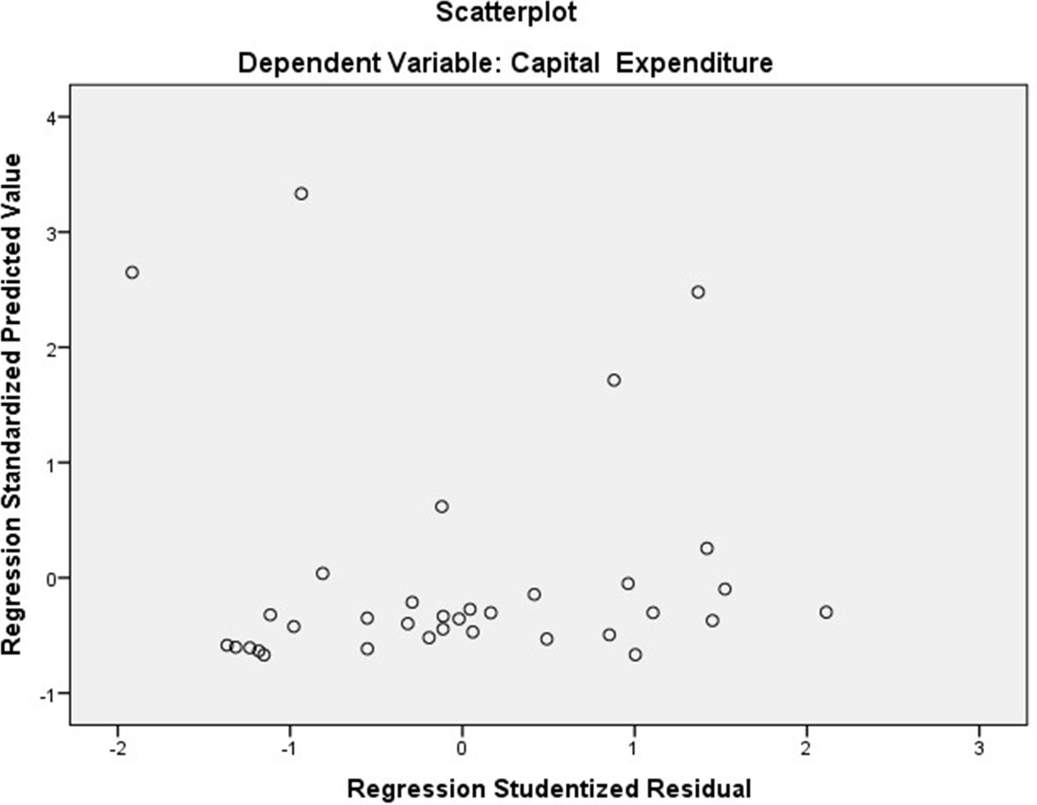

*Data Source: Data Processing Results, 2023.*

Based on the above image, it can be explained that the data processing points are scattered both below and above the origin point (number 0) on the Y-axis, indicating there is no heteroskedasticity or homoscedasticity.

**Multicollinearity Test**

According to (Priyatno, 2018), a good regression model should not have a perfect or near-perfect correlation between the independent variables. The common method for testing multicollinearity is by looking at the values of Tolerance and Variance Inflation Factor (VIF) in the regression model, where a VIF value is less than 10 and has a Tolerance number of more than 0.1.

**Table 4.** Multicollinearity Test Results

|  |  |  |
| --- | --- | --- |
| Variable | *Tolerance* | VIF |
| Regional Original Income (X1) | 0,994 | 1,006 |
| Economic Growth (X2) | 0,994 | 1,006 |

*Data Source: Data Processing Results, 2023.*

Based on the table above, the VIF value of 1,006 < 10 and the Tolerance value of 0,994 > 0,1, it can be concluded that the independent variables, Regional Original Income (X1) and Economic Growth (X2) do not experience multicollinearity.

**Autocorrelation Test**

According to (Ghozali, 2018), the autocorrelation test aims to test whether, in the linear regression model, there is a correlation between disturbance errors in period t and disturbance errors in period t-1 (previous).

**Table 5.** Autocorrelation TestResults

|  |  |
| --- | --- |
| Model | *Durbin-Watson* |
| 1 | 1,715 |

*Data Source: Data Processing Results, 2023.*

Based on the table above, it can be determined that the Durbin-Watson value (d) is 1,715. This value will be compared with the Durbin-Watson table value using a 5% significance level for a sample size (N) of 34 and the number of independent variables (K) of 2. Based on the Durbin-Watson table, it can be seen that the dU value is 1,5805 and the dL value is 1,3325. Therefore, the values of d, dU, and dL meet the fifth criteria with the condition of dU < d < 4 – dU (1,5805 < 1,715 < 2,4195), which means 1.5805 < 1,715 < 2,4195. This testing result indicates that there is no positive or negative correlation.

**Multiple Linear Regression Analysis**

According to (Sujarwaeni, 2015), the purpose of this research is to examine the influence between independent and dependent variables with a scale of measurement or ratio in a linear equation. The regression equation used is:

**Y = a + b1X1 + b2X2 + e**

Information:

Y = Capital Expenditure (Dependent variable)

X1 = Regional Original Income (Independent variable)

X2 = Economic Growth (Independent variable)

a = Constant

b1, b2 = Regression coefficients

e = Error Percentage

**Table 6.** Multiple Linear Regression Analysis Results

|  |  |  |  |  |
| --- | --- | --- | --- | --- |
| Model | | Unstandardized Coefficients | | Standardized Coefficients Beta |
| B | Std. Error |  |
| 1 | *(Constant)* | 55,144 | 5,724 |  |
| *Regional Original Income* | 0,001 | 0,000 | 0,765 |
| *Economic Growth* | 0,226 | 0,771 | 0,034 |

*Data Source: Data Processing Results, 2023.*

Based on the table above, it can be determined that the equation for multiple linear regression analysis in this study is:

**Capital Expenditure = 55,144 + 0,001 Regional Original Income + 0,226 Economic Growth + e**

The analysis result of the constant (a) at 55,144 indicates that if the variables Regional Original Income (X1) and Economic Growth (X2) are valued at 0 or absent, then the value of Capital Expenditure is 55,144 units. The regression coefficient for the variable Regional Original Income is 0,001, indicating that if the values of the other independent variables remain at 0 and Regional Original Income increases by 1 unit, then Capital Expenditures will increase by 0,001 unit. The regression coefficient for the variable Economic Growth is 0,226, indicating that if the values of the other independent variables remain at 0 and Economic Growth increases by 1 unit, then Capital Expenditure will increase by 0,226 units.

**T-Test**

According to (Priyatno, 2018), the T-test is used to determine whether partially the independent variable has a significant influence on the dependent variable with a significance level of 0,05 and two-tailed testing.

**Table 7.** T Test Result

|  |  |  |  |
| --- | --- | --- | --- |
| Model | | *t* | *Sig.* |
|
| 1 | *(Constant)* | 9,634 | 0,000 |
| *Regional Original Income* | 6,570 | 0,000 |
| *Economic Growth* | 0,293 | 0,771 |

*Data Source: Data Processing Results, 2023.*

The T-table value for 34 provinces, α = 0.05 with a two-tailed test is 2.037, which is obtained by using the degree of freedom (df) = sample size (N) – number of independent variables (k) = 34 – 2 = 32.

The result of the analysis shows that the variable Regional Original Income (X1) has a T count of 6,570 > T table 2,037 with a significance value of 0,000 < 0,05. Therefore, it can be concluded that Regional Original Income has a significant partial influence on Capital Expenditure in Indonesia in the Digital Era of 2022. The variable Economic Growth (X2) has a T count of 0,293 < T table 2,037 with a significance value of 0,771 > 0,05. This indicates that Economic Growth does not have a significant influence on Capital Expenditure in Indonesia in the Digital Era of 2022.

**F-Test**

According to (Priyatno, 2018), the F-test is used to determine whether the independent variables have a significant simultaneous influence on the dependent variable with a significance level of 0,05.

**Table 8.** F Test Result

|  |  |  |  |
| --- | --- | --- | --- |
| Model | | *F* | *Sig.* |
| 1 | Regression | 21,602 | 0,000 |
| Residual |  |  |
| Total |  |  |

*Data Source: Data Processing Results, 2023.*

The F-table value for 34 provinces, α = 0,05 is 3,30, which is obtained by using the degree of freedom (df) = sample size (N) - total number of variables (k) = 34 – 3 = 31.

The result of the analysis shows that the calculated F count of 21,602 > the F table value 3,30 with a significance value of 0.000 < α value of 0,05. Therefore, it can be concluded that both Regional Original Income (X1) and Economic Growth (X2) have a significant simultaneous influence on Capital Expenditures in Indonesia in the Digital Era of 2022.

**Coefficient of Determination Test**

According to (Ghozali, 2018), the coefficient of determination test is used to measure how well the model can explain the variation in the dependent variable. The value of the coefficient of determination is between zero and one. A value close to one means that the independent variables provide almost all the information needed to predict the variation in the dependent variable.

**Table 9.** Coefficient of Determination Test Results

|  |  |  |  |
| --- | --- | --- | --- |
| *Model* | *R* | *R Square* | *Adjusted R Square* |
| 1 | 0,763 | 0,582 | 0,555 |

*Data Source: Data Processing Results, 2023.*

The analysis shows that the R Square value of 0,582, which means that 58.2% of the Capital Expenditure variable can be explained by Regional Original Income (X1) and Economic Growth (X2). While the remaining 41.8% of the Capital Expenditure variable can be explained by other variables not examined in this research.

**DISCUSSION**

**Regional Original Income on Capital Expenditure**

Based on the results of the partial test regarding the influence of Regional Original Income, the calculated T count of 6,570 > T table 2,037, with a significance level of 0,000 < 0,05, indicates that Regional Original Income significantly affects Capital Expenditure in Indonesia in the Digital Era of 2022. Therefore, it can be concluded that H1 is accepted. This result aligns with prior research conducted by Muntazar et al. (2020), Suprayitno (2015), and Prasetyo et al. (2022).

**Economic Growth on Capital Expenditure**

Based on the results of the partial test regarding the influence of Economic Growth, the calculated T count of 0,293 < T table 2,037, with a significance level of 0,771 > 0,05, indicates that Economic Growth does not have a significant influence on Capital Expenditure in Indonesia in the Digital Era of 2022. Therefore, it can be concluded that H2 is rejected. This result aligns with prior research conducted by Jaya and Dwirandra (2014), Syukri and Hinaya (2019), and Nurdiwaty et al. (2017).

**Regional Original Income and Economic Growth on Capital Expenditure**

Based on the results of the simultaneous test regarding the influence of Regional Original Income and Economic Growth, the calculated F count of 21,602 > F table 3,30, with a significance level of 0,000 < 0,05, indicates that both Regional Original Income and Economic Growth significantly affect Capital Expenditure in Indonesia in the Digital Era of 2022. Therefore, it can be concluded that H3 is accepted. This result aligns with prior research conducted by Ayem and Pratama (2018) and Syukri and Hinaya (2019).

**CONCLUSION**

The research results show that partially, the Regional Original Income variable significantly affects Capital Expenditure in Indonesia in the Digital Era of 2022. The research also shows that Economic Growth does not have a significant influence on Capital Expenditure in Indonesia in the Digital Era of 2022. Simultaneously, both Regional Original Income and Economic Growth significantly affect Capital Expenditure in Indonesia in the Digital Era of 2022. Based on the coefficient of determination test results, it is known that Regional Original Income and Economic Growth can explain the relationship with Capital Expenditure. In addition to the variables of Regional Original Income and Economic Growth, Capital Expenditure can also be influenced by variables not examined in this study, such as balance funds, general allocation funds, and special allocation funds.

**REFERENCES**

Adur, V. R., Apriyanto, G., & Sutriswanto. (2019). Impact of pure regional income (PAD), general allocation funds (DAU) and special allocation funds (DAK) toward capital expenditures and its impact on economic growth (Case Study of Local Government in Malang Area). *International Journal of Academic Research and Development 4(6)*, 10-19.

Andaiyani. (2013). Pengaruh Indeks Pembangunan  Manusia, Pertumbuhan Ekonomi, dan Belanja  Operasional Terhadap Jumlah Alokasi Belanja  Modal Pada Pemerintahan Kabupaten/Kota  di Provinsi Kalimantan Barat. *Jurnal Ekonomi Daerah*, *1*(1).

Ansofino, Sari, P. M., Yolamalinda, Dahen, L. D., & Rosya, N. (2020). *Textbook of Development Economics* (Anggraini Villia, Ed.; 1st ed.). STKIP PGRI Sumbar Press.

Anwar, M., Umanailo, M., Suprayitno, & Yusriadi, Y. (2021). The Effect of Regional Original Income and Capital Expenditure Management against Economic Growth of Mamuju Central Regency through Performance Effectiveness Regional Finance. *International Conference on Industrial Engineering and Operations Management* (hal. 3180-3188). Sao Paulo, Brazil: IEOM Society International.

*Badan Pusat Statistik*. (t.thn.). Diambil kembali dari https://www.bps.go.id/: https://www.bps.go.id/subject/11/produk-domestik-bruto--lapangan-usaha-.html

*Badan Pusat Statistik*. (n.d.). Retrieved from https://www.bps.go.id/: https://www.bps.go.id/indicator/52/288/1/-seri-2010-produk-domestik-regional-bruto-per-kapita.html

Bestari, A. R. (2020, Agustus 31). *Kemenkeu*. Diambil kembali dari https://www.djkn.kemenkeu.go.id/: https://www.djkn.kemenkeu.go.id/kanwil-kalselteng/baca-artikel/13355/Kebijakan-Publik-DJKN-dan-Ekonomi-yang-Inklusif-dan-Berdaya-Saing.html#:~:text=World%20Economic%20Forum%20(WEF)%20sendiri,luas%20pada%20seluruh%20lapisan%20masyarakat

Djatmika, G. H. (2022). The Effect Of Regional Income and Balancing Funds on the Allocation of Capital Expenditures in Regencies/Cities Of North Sumatra Province. *Neuro Quantology 20(7)*, 107-114.

*Ekon*. (2022, September 22). Diambil kembali dari https://ekon.go.id/: https://ekon.go.id/publikasi/detail/4560/dukung-laju-pertumbuhan-ekonomi-talenta-digital-dan-rasio-kewirausahaan-terus-diakselerasi

Ghozali, I. (2018). *Multivariate analysis application with the IBM SPSS 25 program 9th edition (9th ed.)* (9th ed., Vol. 9). Univercity Diponegoro Publisher Agency.

Indonesia. (2005). *Peraturan Pemerintah Republik Indonesia Nomor 58 Tahun 2005 tentang Pengelolaan Keuangan Daerah.*

Indonesia. (2007). *Undang-Undang Republik Indonesia Nomor 45 Tahun 2007 tentang Anggaran Pendapatan dan Belanja Negara Tahun Anggaran 2008.*

Jaya, I. P. (2014). Pengaruh Pendapatan Asli Daerah Pada Belanja Modal Dengan Pertumbuhan Ekonomi Sebagai Variabel Pemoderasi. *E-Jurnal Akuntansi Universitas Udayana 7(1)*, 79-92.

*Kemenkeu*. (t.thn.). Diambil kembali dari https://djpk.kemenkeu.go.id/: https://djpk.kemenkeu.go.id/portal/data/apbd

Kusnandar, & Siswantoro, D. (2012). *Pengaruh Dana Alokasi Umum, Pendapatan Asli Daerah, Sisa Lebih Pembiayaan Anggaran, Dan Luas Wiliyah Terhadap Belanja Modal*.

*Law No. 25 of 2007*. (n.d.).

*Law No. 33 of 2004*. (n.d.).

Menteri Keuangan. (2011). *Peraturan Menteri Keuangan Republik Indonesia Nomor 101/PMK.02/2011 tentang Klasifikasi Anggaran.*

Muntazar, M., Ibrahim, R., Lukman, H., & Djalil, M. (2020). The Effect of Regional Original Revenue, General Allocation Funds, and Special Allocation Funds on Capital Expenditures at Regional Governments in Aceh Province, Indonesia. *Cross Current International Journal of Economics, Management and Media Studies 2(3)*, 65-71.

Nurdiwaty, D., Zaman, B., & Kristinawati, E. (2017). Analisis Pengaruh Pertumbuhan Ekonomi, PAD, Dana Perimbangan dan Lain-lain Pendapatan Yang Sah Terhadap Belanja Modal Kabupaten/Kota di Jawa Timur. *Jurnal Aplikasi Bisnis 17(1)*, 43-59.

Prasetyo, L. F., Saleh, M., & Jiuhardi. (2022). Effect of Regional Original Income, Revenue Sharing Fund, and Special Allocation Fund for Capital Expenditure and Its Impact on Economic Growth in the District and City in East Kalimantan. *Budapest International Research and Critics Institute-Journal 5(2)*, 13072-13082.

Pratama, D. D. (2018). Pengaruh Pertumbuhan Ekonomi, Dana Alokasi Umum, Dana Alokasi khusus dan Pendapatan Asli Daerah terhadap Belanja Modal Kabupaten/kota Daerah Istimewa Yogyakarta Periode (2011-2016). *Akuntansi Dewantara 2(2)*, 169-182.

Priyatno, D. (2018). *SPSS: Panduan Mudah Bagi Mahasiswa dan Umum* (Giovanny, Ed.). ANDI.

Sugiyono. (2017). *Metode Penelitian Kuantitatif, Kualitatif, dan R&D.* Alfabeta.

Sugiyono. (2017). *Statistics for Research* (28th ed.). Alfabeta.

Sujarwaeni, V. W. (2015). *Metodologi Penelitian Bisnis & Ekonomi* (1st ed., Vol. 1). PUSTAKABARUPRESS.

Suprayitno, B. (2015). Pengaruh Pertumbuhan Ekonomi, Pendapatan Asli Daerah dan Dana Alokasi Umum terhadap Anggaran Belanja Modal Pemerintah Provinsi di Pulau Jawa. *Jurnal Riset Akuntansi dan Perpajakan 2(1)*, 106-112.

Syukri, M., & Hinaya. (2019). Pengaruh Pertumbuhan Ekonomi, Pendapatan Asli Daerah, Dana Alokasi Umum dan Dana Alokasi Khusus Terhadap Anggaran Belanja Modal Kabupaten & Kota Provinsi Sulawesi Selatan. *JEMMA 2(2)*, 30-37.