**The Influence of Facilities, Company Image and Customer Perception on Purchasing Decisions in Using Expedition Services PT. Delapan Samudera Pratama**

**Putri Mauliza1, Lambok Manurung2, Amril3**

12Management, Universitas Battuta

3Institut Bisnis dan Komputer Indonesia

Sekip Street, Medan, Indonesia

Correspondence Email: [putrimauliza@gmail.com](mailto:putrimauliza@gmail.com)

**ABSTRACT**

This study aims to determine the effect of Facilities, Company Image and Customer Perception on Decision of Buyers at PT. Delapan Samudera Pratama. The population in this research is the consumer from PT. Delapan Samudera Pratama as much as 2,496 respondent. The technique of determining the number of samples used in this study is the Slovin formula and totaling 96 respondents. The results of the analysis show that the Facilities partially has no effect on Decision of Buyers at PT. Delapan Samudera Pratama. The results showed that Company Image and Customer Perception partially have a positive and significant effect on Decision of Buyers at PT. Delapan Samudera Pratama. The results showed that Facilities, Company Image and Customer Perceptions simultaneously have a positive and significant effect on Decision of Buyers at PT. Delapan Samudera Pratama. The results of this study are supported by the value of R Square which mean Facilities, Company Image and Customer Perceptions can explain decisions of buyer and the remaining is influenced by other variables outside of this study such as price, and service quality.

**Keywords:** Facilities ; Company Image ; Customer Perception ; Decision of Buyer.

**INTRODUCTION**

Brand Image is something that is interpreted as a combination of a name, sign, symbol, or design to identify goods and services from a business or group of businesses that are developed into trademarks and differentiate themselves from competitors, create influence and generate value for the company. Corporate image is very important for the continuity of the company. This is because a company that has a good image will make the company gain confidence from customers. In addition, a company that has a good image will make it easier for the company to defeat its competitors. The ease of the company in defeating its competitors is because the company is easier to gain trust from customers. Great customer trust in the company will make the company a top priority in experiencing the decision to use services.

Perception is the process used by customers to select, organize, and/or interpret information input to create a meaningful picture of the world. Perception arises because of external stimuli that will influence a person through their five senses, namely sight, hearing, smell, feeling and touch. The stimulus will be selected, organized and interpreted by each person in their own way. The perception produced by each person is always different so that it allows customers to have different decisions about a product.

Purchasing decisions are an integration process that combines knowledge to evaluate two or more alternative behaviors, and has one of them. Many things can underlie consumers in choosing a product, such as the quality of the product, the shape of the product, the type and benefits of the product, the price of the product. PT. Delapan Samudera Pratama has decreased from year to year. However, from the customer data above, the biggest decline was in 2019. This can happen because the facilities provided by PT. Delapan Samudera Pratama have deteriorated, the company's image among customers has also decreased and also the perception of customers who have begun to trust their products less to be sent using the company's transportation services.

**LITERATURE REVIEW**

1. Purchase Decision

According to Sangadji and Sopiah (2013:123), Consumer Decision Making is a problem-solving process that is directed at targets.

2. Facility

According to Tjiptono (2014:317) facilities are physical resources that must exist before a service is offered to consumers.

3. Corporate Image

According to Firmansyah (2019:23), Brand Image can be defined as a perception that appears in the minds of consumers when remembering a brand of a particular product.

The following is the research hypothesis testing:

H1: It is suspected that there is a significant influence of Facilities on Customer Decisions in Using PT. Delapan Samudera Pratama Expedition Services.

H2: It is suspected that there is a significant influence of Company Image on Customer Decisions in Using PT. Delapan Samudera Pratama Expedition Services.

H3: It is suspected that there is a significant influence of Customer Perception on Customer Decisions in Using PT. Delapan Samudera Pratama Expedition Services.

H4: It is suspected that there is a significant influence of Facilities, Company Image and Customer Perception on Customer Decisions in Using PT. Delapan Samudera Pratama Expedition Services.

The theoretical framework in the research can be seen in the image below:

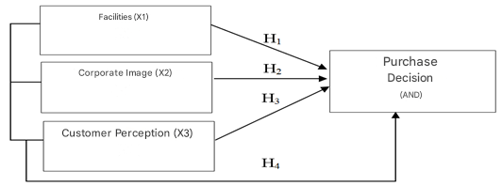

Figure 1. Theoretical Framework

**RESEARCH METHOD**

1. Data Types

This type of research is quantitative research where quantitative data is data in the form of numbers whose characteristics are always in numerical form such as income data, population, consumption levels, bank interest and so on.

2. Population and Sample

The research population that will be used in the study is all consumers at PT. Delapan Samudera Pratama for one year as many as 2,496 people with details, namely in one day PT. Delapan Samudera Pratama customers number 8 customers multiplied by 26 working days and multiplied by 12 months, then in one year the number of customers is 2,496. Based on the reduction of the number of samples with the slovin formula, it is known that the number of samples in this study is 96 respondents.

3. Data collection technique

To obtain relevant data in the study, it is done by means of interviews assisted by research instruments, namely questionnaires given to respondents, direct observation, and literature studies. Data collection techniques through questionnaires will be assessed using a Likert scale.

4. Operational Definition of Research Variables

The following is the operational definition of the variables that will be used, namely:

Table 1. Operational Definition of Research Variables

|  |  |
| --- | --- |
| Variables | Indicator |
| Dependent Variable: |  |
| Purchase Decision (Y) | 1. Decisions About Product Type 2. Decisions About Product Characteristics 3. Decisions About Brands 4. Decisions About Sales 5. Decisions About Product Quantity 6. Decisions About Purchase Time |
| Independent Variables: |  |
| Facility(X1) | 1. Equipment/furniture 2. Supporting elements |
| Corporate Image(X2) | 1. Corporate image 2. User image 3. Product image |
| Customer Perception(X3) | 1. Selective Attention 2. Selective Distortion 3. Selective Retention |

5. Data Analysis Techniques

The data analysis model used in this study is a multiple regression analysis model. Researchers use multiple linear regression because this model is useful for finding the influence between two or more independent variables on the existing dependent variables. The multiple regression equation model is:

|  |  |  |
| --- | --- | --- |
| *Y = a + b1X1 + b2X2 + b3X3 + e* | | *(1)* |
| Information: | |  |
| Y | = Purchase Decision | |
| a | = Constants | |
| b1-2 | = Regression coefficient of independent variables | |
| X1 | = Facility Variables | |
| X2 | = Corporate Image Variables | |
| X3 | = Customer Perception Variables | |
| e | = Standard Error | |

**RESULTS**

1. Respondent Characteristics

Respondent description is a description of the unit being studied including the characteristics of respondents obtained from the questionnaire results. The results of data collection conducted on 96 company consumers were used as respondents, obtained respondent characteristics based on the dominant gender of respondents being male and the dominant age of respondents being 41 years - 50 years.

2. Validity Test and Reliability Test

The results of the Validity and Reliability tests will be presented as follows:

Table 2. Validity Test Results

|  |  |  |
| --- | --- | --- |
| Variables | Statement | rcount |
| Facility(X1) | Statement – 1 | 0,685 |
| Statement – 2 | 0,655 |
| Statement – 3 | 0,852 |
| Statement – 4 | 0,758 |
| Corporate Image(X2) | Statement – 1 | 0,819 |
| Statement – 2 | 0,595 |
| Statement – 3 | 0,578 |
| Statement – 4 | 0,683 |
| Statement – 5 | 0,831 |
| Statement – 6 | 0,920 |
| Customer Perception(X3) | Statement – 1 | 0,499 |
| Statement – 2 | 0,752 |
| Statement – 3 | 0,809 |
| Statement – 4 | 0,487 |
| Statement – 5 | 0,693 |
| Statement – 6 | 0,694 |
| Purchase Decision(Y) | Statement – 1 | 0,640 |
| Statement – 2 | 0,529 |
| Statement – 3 | 0,710 |
| Statement – 4 | 0,648 |
| Statement – 5 | 0,649 |
| Statement – 6 | 0,760 |

Source: Research Results, 2020 (Processed Data)

From the results of Table 2, the calculated r value for each statement item for each variable obtained is above the t table (0.361) so it can be said that the statement used is valid.

Table 3. Reliability Test Results

|  |  |  |
| --- | --- | --- |
| Variables | Number of Items | Cronbach’s Alpha |
| Facility(X1) | 4 | 0,708 |
| Corporate Image(X2) | 6 | 0,834 |
| Customer Perception(X3) | 6 | 0,731 |
| Purchase Decision(Y) | 6 | 0,731 |

Source: Research Results, 2020 (Processed Data)

Based on Table 3, it can be seen that Cronbach's alpha for each variable is above 0.6, so the statement for each variable is declared reliable.

3. Classical Assumption Test

1. Normality Test

The normality test aims to test whether in the regression model the confounding variables or residuals have a normal distribution. There are two ways to detect whether the residuals are normally distributed or not, namely by graphical analysis and statistical tests.

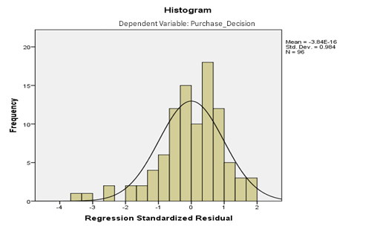

Figure 2. Histogram Graph

Based on Figure 2 above, it can be seen that the data is spread around the diagonal line and follows the direction of the diagonal line or the histogram graph shows a normal distribution pattern, so the regression meets the normality assumption.

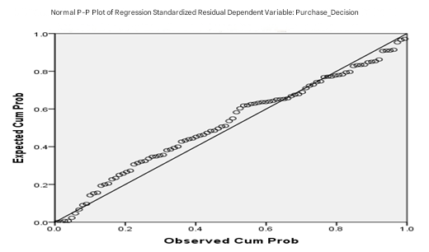

Figure 3. Normal Probability Plot Graph

Based on Figure 3 above, it can be seen that the points approach the diagonal line. This indicates that the data is normally distributed and meets the assumptions of normality testing.

Table 4. Kolmogorov-Smirnov test

One-Sample Kolmogorov-Smirnov Test

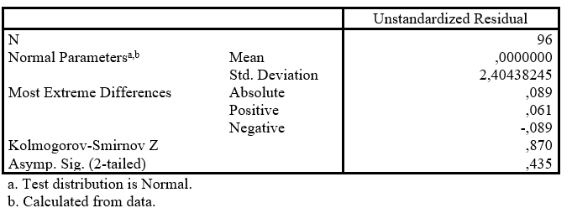

Based on Table 4 above, it can be seen that the results of the Kolmogorov-Smirnov normality test prove that the resulting significance level value is greater than 0.05, namely 0.435, so it can be concluded that the normality statistical test is classified as normally distributed.

B. Multicollinearity Test

The results for the multicollinearity test can be seen in the following table:

Table 5. Multicollinearity Test

Coefficientsa

|  |  |  |  |
| --- | --- | --- | --- |
| Model | | Collinearity Statistics | |
| Tolerance | VIF |
| 1 | (Constant) |  |  |
|  | Facility | ,826 | 1,210 |
|  | Corporate Image | ,674 | 1,485 |
|  | Customer Perception | ,797 | 1,255 |

a. Dependent Variable: Purchase Decision

Source: Research Results, 2020 (Processed Data)

Based on Table 5 above, it can be seen that the correlation value for the facility variable is 0.826, the Vitra brand variable is 0.674 and the perception variable is 0.797 which is more than 0.10 and the VIF value obtained for the facility variable is 1.210, the Corporate Image variable is 1.485 and the perception variable is 1.255 which is less than 10, so it can be stated that there is no multicollinearity problem with other independent variables.

C. Heteroscedasticity Test

The test results using the scatterplot graphic method can be seen in the image below:

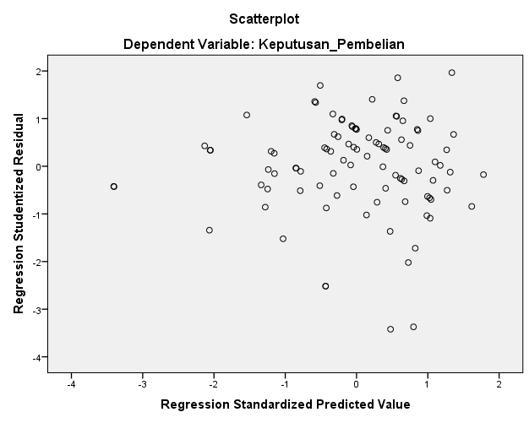

Figure 4. Scatterplot graph

Based on Figure 4 above, it can be seen that the Scatterplot graph points are spread randomly and are spread above and below the number 0 on the Y axis without forming a particular pattern. This can be concluded that there is no heteroscedasticity.

Multiple Linear Regression Analysis Results

The results of the multiple linear regression analysis test can be seen below:

Table 6. Results of Multiple Linear Regression Analysis Test

Coefficientsa

|  |  |  |  |
| --- | --- | --- | --- |
| Model | | Unstandardized Coefficients | |
| B | Std. Error |
| 1 | (Constant) | 4,893 | 1,867 |
|  | Facility | ,011 | ,065 |
|  | Corporate Image | ,312 | ,089 |
|  | Customer Perception | ,555 | ,091 |

Dependent Variable: Purchase Decision

Source: Research Results, 2020 (Processed Data)

|  |  |
| --- | --- |
| Purchase Decision = 4.893 + 0.011 Facilities + 0.312 Company Image  + 0.555 Customer Perception + e | *(2)* |

Based on Table 6 above, a multiple linear regression equation is obtained where if the value of Facilities, Corporate Image and Customer Perception is 0 then the Purchasing Decision remains at 4.893. Every increase in the Facility aspect (X1) by 1 unit, the Purchasing Decision will increase by 0.011. Every increase in the Corporate Image aspect (X2) by 1 unit, the Purchasing Decision will increase by 0.312. Every increase in the Customer Perception aspect (X3) by 1 unit, the Purchasing Decision will increase by 0.555.

Hypothesis Testing Results

A. Partial Testing (t-Test)

The results of partial hypothesis testing (t-test) can be seen in the table below as follows:

Table 7. Partial Test

Coefficients

|  |  |  |  |
| --- | --- | --- | --- |
| Model | | t | Sig. |
| 1 | (Constant) | 2,621 | ,010 |
|  | Facility | ,175 | ,862 |
|  | Corporate Image | 3,494 | ,001 |
|  | Customer Perception | 6,089 | ,000 |

a. Dependent Variable: Purchase Decision

Source: Research Results, 2020 (Processed Data)

The Facility variable (X1) has a tcount value (0.175) > ttable (1.986) with a significant level of 0.862 > 0.05 so it is declared to have no effect. The Corporate Image variable (X2) has a tcount value (3.494) > ttable (1.986) with a significant level of 0.001 < 0.05 and the Customer Perception variable (X3) has a tcount value (6.089) > ttable (1.986) with a significant level of 0.000 < 0.05 so it can be concluded that there is a significant positive influence partially between Corporate Image and Customer Perception on Purchasing Decisions at PT. Delapan Samudera Pratama.

B. Simultaneous Test (F-Test)

The results of simultaneous hypothesis testing (F-Test) can be seen in the table below as follows:

Table 8. Simultaneous Test

ANOVAb

|  |  |  |  |  |  |  |
| --- | --- | --- | --- | --- | --- | --- |
| Model | | Sum of Squares | df | Mean Square | F | Sig. |
| 1 | Regression | 548,039 | 3 | 182,680 | 30,602 | ,000b |
| Residual | 549,200 | 92 | 5,970 |  |  |
| Total | 1097,240 | 95 |  |  |  |

a. Predictors: (Constant), Customer Perception, Company Image, Facilities

b. Dependent Variable: Purchase Decision

Source: Research Results, 2020 (Processed Data)

Based on Table 8, it can be seen that the F count value (30.602) > F table (2.70) with a significance of 0.00 < 0.05, so it is concluded that there is a significant and positive influence between Facilities, Company Image and Customer Perception simultaneously on Purchasing Decisions at PT. Delapan Samudera Pratama.

C. Coefficient of Determination (Adjusted R2)

Hasil koefisien determinasi (Adjusted R2) dapat dilihat dibawah:

Table 9. Determination Coefficient Test

Model Summaryb

|  |  |  |  |  |
| --- | --- | --- | --- | --- |
| Model | R | R Square | Adjusted R Square | Std. Error of the Estimate |
| 1 | ,707a | ,499 | ,483 | 2,44327 |

a. Predictors: (Constant), Customer Perception, Company Image, Facilities

b. Dependent Variable: Purchase Decision

Source: Research Results, 2020 (Processed Data)

Based on Table 9 above, it can be seen that the Adjusted R Square determination coefficient used to measure how far the model's ability to explain the variation of the dependent variable is 0.483. This shows that 48.3% of customer decisions towards PT. Delapan Samudera Pratama are influenced by the variables of facilities, Company Image and perception, while the remaining 51.7% are influenced by other variables such as price and promotion.

Discussion of Research Results

A. The Influence of Facilities on Purchasing Decisions

Based on the results of partial hypothesis testing using the t-test, it is known that the Facilities variable has a positive and significant effect on the Purchasing Decision of PT. Delapan Samudera Pratama.

The results of this study are also in line with research conducted by Gama, et al. (2018), entitled The Influence of Location, Facilities, and Services on Purchasing Decisions (Study on the Guwang Sukawati Art Market) which states that partially facilities have a significant effect on a person's purchasing decision.

B.The Influence of Corporate Image on Purchasing Decisions

Based on the results of partial hypothesis testing using the t-test, it is known that the Corporate Image variable has a positive and significant effect on the Purchasing Decision of PT. Delapan Samudera Pratama.

The results of this study are also in line with research conducted by David, et al. (2016), entitled The Influence of Corporate Image on Consumer Purchasing Decisions of PT. Garuda Indonesia Tbk (Persero) which states that partially corporate image has a significant effect on a person's purchasing decision.

C. Influence of Customer Perception on Purchasing Decisions

Based on the results of partial hypothesis testing using the t-test, it is known that the Customer Perception variable has a positive and significant effect on the Purchasing Decision of PT. Delapan Samudera Pratama.

The results of this study are also in line with research conducted by Mantik, et al. (2015), entitled Consumer Motivation and Perception: Their Influence on Purchasing Decisions at KFC Mega Mall Manado, which states that partially perception has a significant effect on a person's purchasing decision.

D. The Influence of Facilities and Company Image on Purchasing Decisions

Based on the results of simultaneous hypothesis testing using the F-test, it is known that the variables of Facilities, Company Image and Customer Perception have a positive and significant effect on the Purchasing Decision of PT. Delapan Samudera Pratama.

The results of this study are also in line with research conducted by Karlina (2015), entitled Gama, et al. (2018), entitled The Influence of Location, Facilities, and Services on Purchasing Decisions (Study at the Guwang Sukawati Art Market) which states that simultaneously facilities, company image and perception have a significant effect on a person's purchasing decision.

**CONCLUSION**

Based on the results and discussion of the study, the author makes several conclusions as follows:

1. The results of this study state the influence of Facilities, Company Image and Customer Perception on Purchasing Decisions shown from the results of multiple linear regression analysis, meaning that every increase in aspects of the variables Facilities, Company Image and Customer Perception by one unit, the Purchasing Decision will increase
2. The results of the hypothesis test show a positive and significant influence of facilities on Customer Decisions in Using PT. Delapan Samudera Pratama Expedition Services.
3. The results of the hypothesis test show a positive and significant influence of company image on Customer Decisions in Using PT. Delapan Samudera Pratama Expedition Services.
4. The results of the hypothesis test show a positive and significant influence of perception on Customer Decisions in Using PT. Delapan Samudera Pratama Expedition Services.
5. The results of simultaneous hypothesis testing show a positive and significant influence of facilities, company image and customer perception on Customer Decisions in Using PT. Delapan Samudera Pratama Expedition Services.
6. The coefficient of determination explains the relationship between Customer Decisions in Using PT. Delapan Samudera Pratama Expedition Services.

**REFERENCES**

Arianty, Nel, D. A. dan H. J. (2015). *Manajemen Pemasaran* (Pertama). Perdana Publishing.

Agus Wahyudi Salasa Gama1), Ni Wayan Rustiarini2), N. P. N. A., & Fakultas Ekonomi, U. M. D. (2016). *( Studi Pada Pasar Seni Guwang Sukawati )*. *11*(1), 22–30.

Firmansyah, M. A. (2018). *Perilaku Konsumen (Sikap dan Pemasaran)* (Pertama). Grup Penerbit CV Budi Utama.

Ghozali, I. (2013). Aplikasi Analisis Multivariate Dengan Program IBM dan SPSS 21. In *Aplikasi Analisis Multivariate dengan Pogram iIBM SPSS 21*. https://doi.org/10.1126/science.1158668

Hasan, A. (2013). Marketing dan Kasus - Kasus Pilihan. In *Yogyakarta. CAPS (Center For Academic Publishing Service)*. <https://doi.org/10.1007/978-1-> 4471-4315-4

Handyanto widjojo. (2018). *Sari-Sari Pemasaran dan Aplikasinya di Dunia Bisnis* (Kedua). Prasetiya Mulya Publishing.

Kotler, P., & Keller, K. L. (2009). Manajemen pemasaran Jilid 1. In *Jakarta*.

Mantik, A., Mananeke, L., & Tawas, H. (2015). Motivasi Dan Persepsi Konsumen Pengaruhnya Terhadap Keputusan Pembelian Di Kfc Megamall Manado. *Jurnal Riset Ekonomi, Manajemen, Bisnis Dan Akuntansi*, *3*(1), 378–387.

Mauliansyah, R. (2015). *Analisis Pengaruh Motivasi , Persepsi Kualitas dan Sikap Konsumen terhadap Keputusan Pembelian Sepeda Motor Honda di Kota Langsa*. *4*(1), 317–328.

Nitisusastro, D. H. M. (2013). *Perilaku Konsumen Dalam Perspektif Kewirausahaan* (Kedua). CV. Alfabeta.

Pratama, A. F., Niaga, A., & Malang, P. N. (2018). *KEPUTUSAN PEMBELIAN ( Studi Pada Pembelian Honda Brio Di Dealer Honda Sukun Malang )*.

Priansa, D. J. (2017). *Komunikasi Pemasaran Terpadu* (Pertama). CV Pustaka Setia.

Priansa, D. J. (2017). *Perilaku Konsumen Dalam Persaingan Bisnis Kontemporer* (Kesatu). CV. Alfabeta.

Robbins, S. P., & Judge, T. A. (2015). *Perilaku Organisasi*. Salemba Empat.

Sangadji, E. M. dan S. (2013). Perilaku Konsumen : Pendekatan Praktis Disertai Himpunan Jurnal Penelitian. *Penerbit Salemba*.

Setiadi, D. N. J. (2010). *Perilaku Konsumen* (Keempat). Kencana Pernada Media Group.

S.E., M. (2013). Pengaruh Citra Perusahaan, Citra Produk dan Citra Pemakai Terhadap Keputusan Pembelian Produk Foremost pada Distro Ruby Soho di Singaraja. *Jurnal Jurusan Manajemen*, *2*(1).

Sugiyono. (2013). Metode Penelitian Pendidikan Pendekatan Kuantitaif, Kualitatif, dan R&D. Bandung CV alfabeta. *Metode Penelitian Pendidikan Pendekatan Kuantitaif, Kualitatif, Dan R&D*.

Sunyoto, D. (2014). *Konsep Dasar Riset Pemasaran & Perilaku Konsumen* (Pertama). CAPS.

Tjiptono, F., & Chandra, G. (2014). Manajemen Kualitas Jasa. *Yogyakarta. ANDI*. <https://doi.org/10.12691/jbms-4-4-1>

Wibowo, L. A., & Priansa, D. J. (2017). Manajemen Komunikasi Dan Pemasaran. Alfabeta.