**The Effect of Financial Behavior and Income Level on Investment Decision in Digital Era**

**Wilson1, Frenky Situmorang2, Putri Wahyuni3**

STIE Eka Prasetya Medan

Jl. Merapi No.8, Pusat Ps., Kec. Medan Kota, Kota Medan, Sumatera Utara, 20212

Wilsonyang37@gmail.com

**ABSTRACT**

This study aims to determine whether financial behavior and income level have a significant effect on investment decisions of STIE Eka Prasetya permanent lecturers. This study uses quantitative data method and the data source is primary data. The population in this study are all permanent lecturers who taught at STIE Eka Prasetya, totaling 33 permanent lecturers. The sample in this study includes all permanent lecturers teaching at STIE Eka Prasetya, using a saturated sampling method. Data analysis and testing consist of validity test, reliability test, descriptive statistics, the classical assumption test, multiple regression analysis, partial hypothesis testing (T test), simultaneous hypothesis testing (F test), and coefficient of determination test (R²). The results of this study indicate that financial behavior has a significant effect on investment decisions with a calculated T-count of 2.113 > T-table of 2.039. Income Level does not have a significant effect on investment decisions with a calculated T-count of 0.821 < T-table of 2.039. Financial behavior and income level have a significant effect on investment decisions with a calculated F-count of 4.569 > F-table of 3.32 and a regression coefficient value of 23.3%.

**Keywords:** Financial Behavior; Income Level; Investment Decisions

**INTRODUCTION**

The digital era is always associated with rapid technological advancement, which greatly facilitates conventional aspects of life easier through technology. As technology continues to advance, financial activities such as investing and saving can be done online, making it easier for individuals to manage their finances. Investment is one of the economic activities that can yield both high profits and high losses. Therefore, it is essential to have knowledge about investments to increase the level of investment in Indonesia and make it more profitable.

**Figure 1**. Growth Investors

Data Source: Indonesian Central Securities Depository (KSEI), 2023

Based on the data graph above, it is evident that the number of investors continues to increase each year, driven by technological developments that introduce various applications for starting investments. According to data from the (Indonesian Central Securities Depository (KSEI) 2023), the total number of capital market investors throughout 2022 reached 10.31 million, showing an increase of 37,68% compared to the 2021 period, which recorded 7.49 million investors. This figure refers to the total count of Single Investor Identification (SID), and over the past five years, the number of investors in Indonesia has increased more than fivefold, specifically by 536,24%.

One factor to improve investment decisions is by adopting good and prudent financial behavior. Financial behavior is observed in how an individual treats, uses, and manages their finances. Individuals with good financial behavior typically use their funds effectively, such as creating a budget, managing expenses, saving, investing, paying off debts, and preparing for emergencies (DM 2021). Therefore, possessing good financial behavior is essential for every individual to manage their finances and make informed investment decisions.

Another factor to improve investment decisions in the digital era is the income level of each individual. The higher a person's income, the more they will strive to understand how to make the best use of their money and expand their financial knowledge about investments (Rahman and Yulian 2022). Conversely, lower income levels may only suffice for meeting the basic needs of each individual. Therefore, it is necessary to increase income levels in order to meet basic needs, have savings, and invest.

**LITERATURE REVIEW**

**Investment Decisions**

According to (Purnamasari, Kurniawati, and Silvi 2009:4), investment decisions are decisions that involve allocating funds originating both from within and outside the company in various forms of investments. According to (Tandelilin 2010:9) indicators of investment decisions are: 1. Expected return rate; 2. Level of risk; 3. Relationship between return and risk.

**Financial Behavior**

According to (Suriani 2022:2), financial behavior is a relatively new field of study that aims to integrate theories of behavioral and cognitive psychology with conventional economics and finance to explain why people make irrational financial decisions. According to (Nababan and Sadalia 2012:12), indicators of financial behavior are: 1. Paying bills on time; 2. Creating a budget for expenses and shopping; 3. Recording expenses and shopping (daily, monthly, etc.); 4. Providing funds for unexpected expenses; 5. Saving.

**Income Level**

According to (Iskandar 2017:3), Income Level refers to the standard of living that an individual or family can enjoy based on their earnings or other sources of income. According to (Bramastuti 2009:48), indicators of income level are: 1. Monthly income received; 2. Occupation; 3. School expenses budget; 4. Family burdens borne.

Based on the description above and the results of previous research, the variables in this study can be seen in the research framework diagram, which are:

**Figure 2.** Framework

Investment Decisions

Income Level

Financial Behavior

H₁

H₃

H₂

The hypotheses in this study are:

H₁: Financial behavior has a significant effect on investment decisions in the digital era of STIE Eka Prasetya permanent lecturers.

H₂: Income level has a significant effect on investment decisions in the digital era of STIE Eka Prasetya permanent lecturers.

H₃: Financial behavior and Income Level have a significant effect on investment decisions in the digital era of STIE Eka Prasetya permanent lecturers.

**RESEARCH METHOD**

The research was conducted at the campus of STIE Eka Prasetya, located at Jl. Merapi No.8, Pusat Pasar, Medan Kota District, Medan City, 20212. It started from July 1st to October 10th, 2023. This study utilized quantitative data by distributing questionnaires online via Google Form to the lecturers on campus. The questionnaires contained statements related to the research variables, measured on a likert scale ranging from 1 to 5.

This research uses primary data. The population for this study consists of all permanent lecturers who serve as educators at STIE Eka Prasetya, totaling 33 lecturers. The data for this research were collected using a saturation sampling technique, where the entire population in the study was taken as samples.

Data analysis and testing consist of: 1. Validity test; 2. Reliability test; 3. Descriptive statistics test; 4. Normality test; 5. Multicollinearity test; 6. Heteroscedasticity test; 7. Multiple linear regression analysis; 8. Partial significance test (T Test); 9. Simultaneous significance test (F Test); 10. Coefficient of determination test (R²).

**RESULTS**

**Validity Test**

According to (Priyatno 2018:21), the validity test is used to assess how accurately an item measures what is intended. Significance testing is conducted using the r-table criteria at a significance level of 0.05 with a two-sided test. If the positive value and the calculated r-count > the r-table, the item can be considered valid. Conversely, if the calculated r-count < the r-table, the item is considered not valid.

**Table 1.** Validity test results

|  |  |  |  |
| --- | --- | --- | --- |
| No. | R-count | R-table | Description |
| X₁ Q1 | 0,460 | 0,344 | Valid |
| X₁ Q2 | 0,363 | 0,344 | Valid |
| X₁ Q3 | 0,708 | 0,344 | Valid |
| X₁ Q4 | 0,798 | 0,344 | Valid |
| X₁ Q5 | 0,486 | 0,344 | Valid |
| X₁ Q6 | 0,420 | 0,344 | Valid |
| X₁ Q7 | 0,420 | 0,344 | Valid |
| X₁ Q8 | 0,590 | 0,344 | Valid |
| X₁ Q9 | 0,682 | 0,344 | Valid |
| X₁ Q10 | 0,518 | 0,344 | Valid |
| X₂ Q1 | 0.472 | 0,344 | Valid |
| X₂ Q2 | 0,451 | 0,344 | Valid |
| X₂ Q3 | 0,370 | 0,344 | Valid |
| X₂ Q4 | 0,769 | 0,344 | Valid |
| X₂ Q5 | 0,718 | 0,344 | Valid |
| X₂ Q6 | 0,759 | 0,344 | Valid |
| X₂ Q7 | 0,818 | 0,344 | Valid |
| X₂ Q8 | 0,783 | 0,344 | Valid |
| Y Q1 | 0,675 | 0,344 | Valid |
| Y Q2 | 0,698 | 0,344 | Valid |
| Y Q3 | 0,420 | 0,344 | Valid |
| Y Q4 | 0,833 | 0,344 | Valid |
| Y Q5 | 0,817 | 0,344 | Valid |

Data Source: Data Processing results, 2023

The analysis results indicate that the validity coefficients range from 0.363 to 0.833, while the critical r-table at a 5% significance level for a sample size of 33 respondents is 0.344. It is evident that the validity coefficients for all questionnaire items are greater than the critical r-table. Based on these results, it can be concluded that the questions used in the research variable are valid.

**Reliability Test**

According to (Priyatno 2018:25), reliability testing is used to determine the accuracy or consistency of a measurement instrument, which typically involves the use of a questionnaire. The method to calculate reliability is by calculating the Cronbach's Alpha reliability coefficient. To determine whether the instrument is reliable or not, a threshold of 0.6 is used.

**Table 2.** Reliability test results

|  |  |  |
| --- | --- | --- |
| Variable | *Cronbach’s Alpha* | Description |
| Financial Behavior (X₁) | 0,739 | Reliable |
| Income Level (X₂) | 0,801 | Reliable |
| Investment Decisions (Y) | 0,739 | Reliable |

Data Source: Data Processing results, 2023

The results of the analysis show that both the independent and dependent variables have Cronbach's Alpha values above 0.6. Based on these results, it can be concluded that all instruments are reliable and can be used for the research.

**Descriptive Statistics Test**

According to (Priyatno 2018:41), descriptive statistics are used to depict data statistics such as mean, sum, standard deviation, variance, range, and others.

**Table 3.** Descriptive statistics test results

|  |  |  |  |  |  |
| --- | --- | --- | --- | --- | --- |
| Variable | N | Min. | Max. | Mean | Std. Deviation |
| Financial Behavior (X₁) | 33 | 34 | 50 | 41,91 | 4.193 |
| Income Level (X₂) | 33 | 15 | 36 | 28,88 | 4.702 |
| Investment Decisions (Y) | 33 | 16 | 25 | 21,21 | 2.382 |

Data Source: Data Processing results, 2023

The analysis results indicate that a total of 33 permanent lecturers from STIE Eka Prasetya were included in the study. The variable of financial behavior (X₁) with a minimum value of 34 and a maximum value of 50 has an average of 41.91 and a data distribution level of 4.193. The variable of income level (X₂) with a minimum value of 15 and a maximum value of 36 has an average of 28.88 and a distribution level of 4.702. The investment decision variable (Y) with a minimum value of 16 and a maximum value of 25 has an average of 21.21, and a distribution level of 2.382.

**Normality Test**

According to (Priyatno 2018:127), the normality test is used to test whether the residuals generated from regression are normally distributed or not. A good regression model is one that has normally distributed residuals. In this study, to test the normality of the data, the researcher uses Histogram test, P-Plot, and Kolmogorov–Smirnov with a significance level of 0.05.

**Table 4.** Kolmogorov-Smirnov normality test results

|  |  |  |
| --- | --- | --- |
|  | | Unstandardized Residual |
| N | | 33 |
| Normal Parameters | Mean | .0000000 |
| Std. Deviation | 2.08515957 |
| Most Extreme Differences | Absolute | .085 |
| Positive | .085 |
| Negative | -.076 |
| Test Statistic | | .085 |
| Asymp. Sig. (2-tailed) | | .200 |

Data Source: Data Processing results, 2023

Based on the normality test results using the Kolmogorov-Smirnov test, the Asymp. Sig (2-tailed) value obtained is 0.200. Therefore, it can be concluded that the regression equation model is normally distributed because the Asymp. Sig (2-tailed) value is greater than the alpha value of 0.05.

**Figure 3.** Histogram normality test results

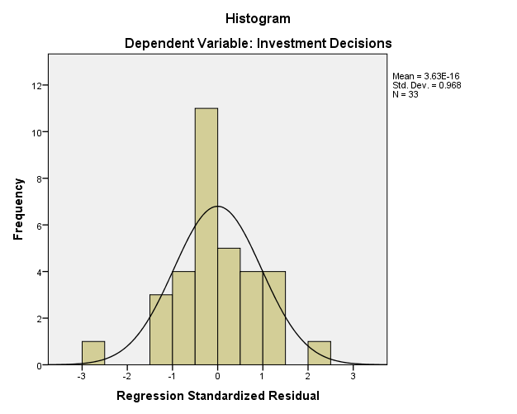

Data Source: Data Processing results, 2023

Based on the normality test results using the histogram test, an image with a line forming a peak is obtained. If the line forms a peak and appears symmetrical with even slopes, it can be concluded that the data is normally distributed.

**Figure 4.** P-Plot normality test results

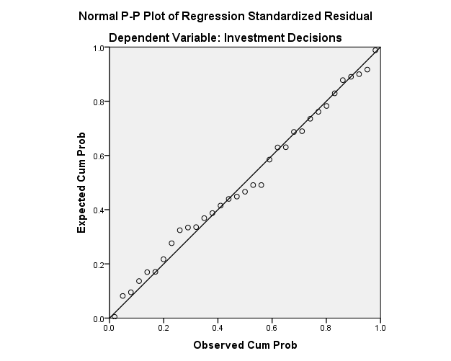

Data Source: Data Processing results, 2023

Based on the normality test results using the P-Plot test, an image with plots that follow the diagonal line is obtained. If the plots follow the diagonal line from point 0 and do not spread too far, it can be concluded that the data is normally distributed.

**Heteroscedasticity Test**

According to (Priyatno 2018:136), heteroscedasticity is a condition where there is unequal variance of the residuals from one observation to another in a regression model. A good regression model should not exhibit heteroscedasticity. To detect the presence of heteroscedasticity, it is observed by looking at the patterns of dots on regression scatterplots.

**Figure 5.** Heteroscedasticity test results

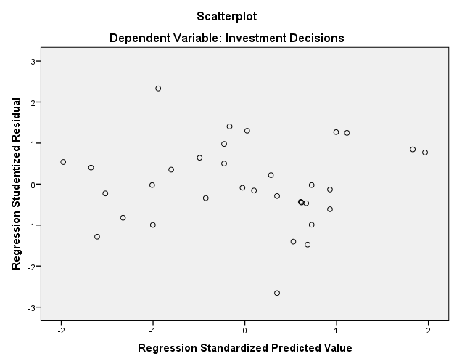

Data Source: Data Processing results, 2023

Based on the above chart, it can be explained that the data processing points are scattered both below and above the origin point (number 0) on the Y-axis, and there is no heteroscedasticity, indicating homoscedasticity.

**Multicollinearity Test**

According to (Priyatno 2018:134), the test for multicollinearity is a situation in a regression model where there is a perfect or near-perfect correlation among independent variables. A good regression model should not have perfect or near-perfect correlations among independent variables. The common method for testing multicollinearity is by looking at the values of Tolerance and Variance Inflation Factor (VIF) in the regression model, where the VIF value should be less than 10 and the Tolerance value should be more than 0.1.

**Table 5.** Multicollinearity test results

|  |  |  |
| --- | --- | --- |
| Variable | *Tolerance* | VIF |
| Financial Behavior (X₁) | 0,751 | 1,331 |
| Income Level (X₂) | 0,751 | 1,331 |

Data Source: Data Processing results, 2023

Based on the table above, the VIF value of 1.331 < 10 and the tolerance value of 0.751 > 0.1. Therefore, it can be concluded that the independent variables, financial behavior (X₁) and income level (X₂), do not experience multicollinearity.

**Multiple Linear Regression Analysis**

According to (Priyatno 2018:40), multiple linear regression analysis is used to determine whether there is a significant partial or simultaneous influence between two or more independent variables on one dependent variable. The equation for multiple regression can be formulated as follows:

**Y = α + b₁X₁ + b₂X₂ + e**

Description:

Y = Investment Decision

X₁ = Financial Behavior

X₂ = Income Level

α = Constant

b₁, b₂ = Regression Coefficients

e = Error Percentage

**Table 6.** Multiple linear regression analysis test results

|  |  |  |  |  |
| --- | --- | --- | --- | --- |
| Model | | Unstandardized Coefficients | | Standardized Coefficients |
| B | Std. Error | Beta |
| 1 | (Constant) | 9,725 | 3,857 |  |
| Financial Behavior | 0,221 | 0,105 | 0,390 |
| Income Level | 0,077 | 0,093 | 0,151 |

Data Source: Data Processing results, 2023

Based on the table above, the equation for multiple linear regression analysis in this study is:

**Investment Decisions = 9,725 + 0,221 Financial Behavior + 0,077 Income Level + e**

The analysis result of the constant (α) at 9.725 indicates that if the variables financial behavior (X₁) and income level (X₂) have a value of 0 or are absent, then the investment decision will be 9.725 units. The regression coefficient of the financial behavior variable at 0.221 shows that if the values of other independent variables remain constant and financial behavior increases by 1 unit, the investment decision will increase by 0.221 units. The regression coefficient of the income level variable at 0.077 indicates that if the values of other independent variables remain constant and the income level increases by 1 unit, the investment decision will increase by 0.077 units.

**Partial Significance Test (T test)**

According to (Priyatno 2018:121), the t-test or partial regression coefficient is used to determine whether an independent variable has a significant partial effect on the dependent variable or not. The test uses a significance level of 0.05 and is a two-tailed test.

**Table 7.** T test results

|  |  |  |  |
| --- | --- | --- | --- |
| Model | | t | Sig. |
|
| 1 | (Constant) | 2.522 | 0.017 |
| Financial Behavior | 2.113 | 0.043 |
| Income Level | 0.821 | 0.418 |

Data Source: Data Processing results, 2023

The t-table value for 33 respondents, α = 0.05 with a two-tailed test is 2.039, obtained by using the degree of freedom (df) = sample size - number of independent variables = 33 – 2 = 31.

The results of the analysis indicate that the financial behavior variable (X₁) has a calculated T-count of 2.113 > T-table of 2.039 with a significance value of 0.043 < 0.05. It can be concluded that financial behavior has a significant effect on investment decisions in digital era (case study of STIE Eka Prasetya permanent lecturers). The income level variable (X₂) has a calculated T-count of 0.821 < T-table of 2.039 with a significance value of 0.418 > 0.05. This implies that the income level does not have a significant effect on investment decisions in the digital era (case study of STIE Eka Prasetya permanent lecturers).

**Simultaneous Significance Test (F test)**

According to (Priyatno 2018:119), The F-test or regression coefficient test is used to determine if independent variables collectively have a significant effect on the dependent variable. According to (Ghozali 2018:98), the criteria for hypothesis testing using the F-statistic is that when the significance value of F < 0.05, the alternative hypothesis is accepted. This states that all independent variables collectively and significantly affect the dependent variable.

**Table 8.** F test results

|  |  |  |  |
| --- | --- | --- | --- |
| Model | | F | Sig. |
| 1 | Regression | 4.569 | 0.019 |
| Residual |  |  |
| Total |  |  |

Data Source: Data Processing results, 2023

The F-table value for 33 respondents, α = 0.05 is 3.32, obtained by using the degree of freedom (df) = sample size (n) – total number of variables (k) = 33 – 3 = 30.

The analysis results indicate that the calculated F-count of 4.569 > F-table of 3.32, with a significance level (sig) of 0.019 < the alpha level (α) of 0.05. Therefore, it can be concluded that financial behavior and income level have a significant effect on investment decisions in digital era (case study of STIE Eka Prasetya permanent lecturers).

**Coefficient of Determination Test (R²)**

According to (Ghozali 2018:97), the coefficient of determination is used to measure how well the model explains the variation in the dependent variable. A value close to one means that the independent variables provide almost all the information needed to predict changes in the dependent variable. Conversely, a small coefficient of determination indicates that the ability of the independent variables to explain the variation in the dependent variable is very limited.

**Table 9.** R² test results

|  |  |  |  |
| --- | --- | --- | --- |
| Model | R | *R Square* | *Adjusted R Square* |
| 1 | 0.483 | 0.233 | 0.182 |

Data Source: Data Processing results, 2023

The analysis results indicate an R Square value of 0.233, meaning that 23.3% of the investment decision (Y) variable can be explained by financial behavior (X₁) and income level (X₂). Meanwhile, the remaining 76.7% of the investment decision variable can be explained by other variables that were not examined in this study, such as risk perception, financial literacy, and financial management.

**DISCUSSION**

**Financial Behavior on Investment Decisions**

Based on the partial test results regarding the effect of financial behavior, the calculated T-count of 2.113 > T-table of 2.039 and the significance level of 0.043 < 0.05. This means that financial behavior has a significant effect on investment decisions in digital era (case study of STIE Eka Prasetya permanent lecturers). Based on this, it can be concluded that H₁ is accepted. The results of this study align with previous research conducted by (Lindananty and Angelina 2021) with their study titled “The Influence of Financial Literacy, Financial Behavior, and Income on Stock Investment Decisions”. They concluded that financial behavior has a significant effect on stock investment decisions.

**Income Level on Investment Decisions**

Based on the partial test results regarding the effect of income level, the calculated T-count of 0.821 < T-table of 2.039 and the significance level of 0.418 > 0.05. This means that income level does not have a significant effect on investment decisions in digital era (case study of STIE Eka Prasetya permanent lecturers). Based on this, it can be concluded that H₂ is rejected. The results of this study align with previous research conducted by (Lindananty and Angelina 2021) with their study titled “The Influence of Financial Literacy, Financial Behavior, and Income on Stock Investment Decisions”. They concluded that income does not have a significant influence on stock investment decisions.

**Financial Behavior and Income Level on Investment Decisions**

Based on the simultaneous test results regarding the effect of financial behavior and income level, the calculated F-count of 4.569 > F-table of 3.32 and the significance level of 0.019 < 0.05. This means that financial behavior and income level have a significant effect on investment decisions in digital era (case study of STIE Eka Prasetya permanent lecturers). Based on this, it can be concluded that H₃ is accepted. The results of this study are in line with previous research conducted by (Yundari and Artati 2021) with their study titled “Analysis of the Effect of Financial Literacy, Financial Behavior, and Income on Investment Decisions”. They concluded that financial literacy, financial behavior and income have a significant effect on investment decisions.

**CONCLUSION**

The research results indicate that partially, financial behavior has a significant effect on investment decisions in digital era (case study of STIE Eka Prasetya permanent lecturers). The research also shows that income level does not have a significant effect on investment decisions in digital era (case study of STIE Eka Prasetya permanent lecturers). Simultaneously, financial behavior and income level have a significant effect on investment decisions in digital era (case study of STIE Eka Prasetya permanent lecturers). Based on the coefficient of determination test results, it is known that financial behavior and income level can define the linkage with investment decisions. Besides financial behavior and income level, investment decisions can also be affected by variables not examined in this study, such as risk perception, financial literacy, and financial management.

**REFERENCES**

Ahmad, Atika. (2019). Dampak *Lotus of Control*, Sikap Keuangan, Pendapatan, dan Religiusitas terhadap Perilaku Keuangan. *Management & Acounting Expose*, 2(2), 105-115. <https://doi.org/10.36441/mae.v2i2.102>

Astiti, N. P. Y., Warmana, G. O., & Hidayah, M. (2019). *Financial Literation and Investment Decision Behavior of Entrepreneurs in Bali. International Journal of Applied Business and International Management.*

<https://doi.org/10.32535/ijabim.v4i3.683>

Atmaningrum, Siska, dkk. (2021). *Investment Decisions: The Results of Knowledge, Income, and Self-Control. Journal of Economics and Business*, Vol.4 No.1 (2021), Available at SSRN: <https://ssrn.com/abstract=3779643>

Bramastuti, N. (2009). Pengaruh Prestasi Sekolah dan Tingkat Pendapatan Keluarga terhadap Motivasi Berwiraswata siswa SMK Bakti Oetama Gondangrejo Karanganyar.

DM, Rustan. (2021). *Financial Literacy, Financial Behavior and Financial Attitudes Towards Investment Decisions and Firm Bankruptcy*. *Atestasi: Jurnal Ilmiah Akuntansi*, *4*(1), 79–87. <https://doi.org/10.57178/atestasi.v4i1.167>

Ghozali, I. (2018). *Aplikasi analisis multivariate dengan program IBM SPSS 25 edisi ke-9* (9th ed.). Universitas Diponegoro.

Hasanudin, dkk. (2022). Pengaruh Literasi Keuangan, Efikasi Keuangan, dan Sikap Keuangan terhadap Keputusan Investasi melalui Perilaku Keuangan. *Jurnal Ilmiah Akuntansi dan Keuangan,* 5(2).

<https://doi.org/10.32670/fairvalue.v5i2.2318>

Indonesian Central Securities Depository (KSEI). (2023). Pertumbuhan SID 2019-2022

Iskandar. (2017). Pengaruh Pendapatan Terhadap Pola Pengeluaran Rumah Tangga Miskin di Kota Langsa. *Jurnal Samudra Ekonomika,* 1(2), 127-134. <https://doi.org/10.1234/jse.v1i2.328>

Lindananty & Meilita. (2021). Pengaruh Literasi Keuangan, Perilaku Keuangan, dan Pendapatan terhadap Keputusan Investasi Saham. *Jurnal Buana Akuntansi*, Vol.6 No.1 <https://doi.org/10.36805/akuntansi.v6i1.1298>

Nababan & Sadalia. (2012). Analysis of Personal Financial Literacy and Financial Behavior of Undergraduate Students, Faculty of Economics, University of North Sumatra. *Media Information Management,* 1(1), 1-16.

Priyatno, D. (2018). *SPSS: Panduan Mudah Bagi Mahasiswa dan Umum* (Giovanny (ed.)). Andi.

Purnamasari, Linda, dkk. (2009). Interdepensi antara Keputusan Investasi, Keputusan Pendanaan dan Keputusan Dividen. *Jurnal Keuangan dan Perbankan* Vol. 13 No. 1, 106-119. <https://dx.doi.org/10.26905/jkdp.v13i1.922>

Rahman, Kristanti & Tri Nurindahyanti, Y. (2022). *The Effect of Financial Behavior and Income on Investment Decisions During the Covid 19 Pandemic with Financial Literacy as an Intervening Variable. Jurnal Ekonomi Keuangan dan Manajemen*, 18(1). <https://doi.org/10.30872/jinv.v18i1.10418>

Reviandi, Wasti. (2019). Pengaruh Pengalaman Keuangan dan Tingkat Pendapatan Terhadap Perilaku Keuangan Keluarga di Desa Yosowilangun Kecamatan Manyar Gresik. ***Jurnal Manajerial***, 6(1), 48-58, ISSN 2621-5055.

<http://dx.doi.org/10.30587/jurnalmanajerial.v6i01.862>

Safryani, U., Aziz, A., & Triwahyuningtyas, N. (2020). Analisis Literasi Keuangan, Perilaku Keuangan, Dan Pendapatan Terhadap Keputusan Investasi. *Jurnal Ilmiah Akuntansi Kesatuan*, *8*(3), 319–332.

<https://doi.org/10.37641/jiakes.v8i3.384>

Soleha, E., & Hartati, N. (2021). Analisis Perilaku Keuangan Mahasiswa Universitas Pelita Bangsa dalam Keputusan Investasi: (Analysis of Universitas Pelita Bangsa Student Financial Behavior in Investment Decisions). *EKOMABIS: Jurnal Ekonomi Manajemen Bisnis*, *2*(01), 59-70.

<https://doi.org/10.37366/ekomabis.v2i01.124>

Sorongan, F. A. (2022). *The Influence of Behavior Financial and Financial Attitude on Investment Decisions with Financial Literature as Moderating Variable. European Journal of Business and Management Research*, *7*(1), 265–268.

<https://doi.org/10.24018/ejbmr.2022.7.1.1291>

Surianti, Seri. (2022). *Financial Behavior.* Medan: Yayasan Kita Menulis.

Tandelilin, E. (2010). *Portofolio dan Investasi: Teori dan Aplikasi Ed. 1.* Yogyakarta: Kanisius

Yundari, Tri. & Dwi A. (2021). Analisis Pengaruh Literasi Keuangan, Perilaku Keuangan dan Pendapatan Terhadap Keputusan Investasi. *Jurnal Ilmiah Mahasiswa Manajemen, Bisnis dan Akuntansi (JIMMBA),* 3(3), 606-622.

<https://doi.org/10.32639/jimmba.v3i3.896>