STUDENT’S PERCEPTION TOWARDS SERVICES QUALITY OF ZAKAT DISTRIBUTION IN EDUCATION ISTITUTION

## Nor Linda Binti Mokhtar1

Commerce Department, Polytechnic Ungku Omar, Ipoh, Perak1 Jalan Raja Musa Mahadi, 31400. Malaysia. [nlinda.mokhtar@puo.edu.my](mailto:nlinda.mokhtar@puo.edu.my)

# ABSTRACT

The distribution of zakat in Malaysia should be able to reduce poverty in society and help zakat recipients in fulfilling their needs. The study is to know about student’s perception towards services quality of zakat distribution. The purpose of this research is to determine the level of student’s perception towards services quality of zakat distribution and to determine the relationship between tangibles, reliability, responsiveness, assurance and empathy towards student’s perception on zakat distribution. A student’s survey questionnaire was utilized as the primary research instrument for this study. The questionnaire for this study consisted of 35 items in three parts that were Part A, Part B and Part C by using the 5 Likert scale. This study involved students in all department at Polytechnic Ungku Omar (PUO) which are from 3rd to 5th semester who receiving zakat in session December 2021 until June 2023. Descriptive analysis for 255 respondents was obtained from questionnaire based on mean of the main research variables. The overall mean of student’s perception is 4.2840, tangibles is 4.0980, reliability is 4.3080, responsiveness is 4.2100, assurance is 4.2820 and empathy is 4.3040. The study shows that medium relationships among responsiveness, reliability, assurance and students’ perception towards services quality of zakat distribution. Therefore, the institution should improve all service quality to gain stronger relationship such as by sending staff to attend courses to be more open in solving problems, training staff to have more skills and be prepared to face the zakat contestants, provide classes and instructors for new staff to be more vulnerable knowledge related to zakat. Thus, students will feel trust and relying solely on the institution. Lastly, the researchers need to expand the number of respondents in order to know more results about zakat perception among students and including more institutions.

**Keywords:** Student’s Perception, Tangibles, Reliability, Responsiveness, Assurance, Empathy, Zakat.

# INTRODUCTION

Zakat, as defined in Islamic tradition, is a form of obligatory alms giving that involves taking a portion of one's wealth or property, based on specific criteria, and distributing it to eligible individuals or groups known as *asnaf*. The primary purpose of zakat is to address social and economic inequality, alleviate poverty, and improve the well-being of the less fortunate in society. However, it's important to note that the successful implementation of zakat as a poverty alleviation tool depends on several factors, including proper governance, transparency, accountability and awareness within the Muslim community. Additionally, addressing poverty comprehensively may require the collaboration of various social and economic initiatives in addition to zakat. Efforts to improve the management and distribution of zakat can indeed contribute to addressing poverty-related challenges in Malaysia and other regions where zakat is practiced.

Zakat institution has offered various services to improve such fund (Azman et al., 2012; Zainal et al., 2016). One of the services include corporatization of collection and distribution centre. The issue of service quality is being also critical to zakat institution considering provides numerous services to the Muslim community. One of the issues is inefficiency in the distribution of zakat as well as the surplus of zakat funds that are not distributed to the eligible *asnaf* (Hairunnizam et al., 2012; Hairi and Hussain, 2009; Raudha et al., 2011; Sanep and Hairunnizam, 2005b). Thus, the services need to be evaluated (Sulaiman and Jamil, 2015; Azura and Saad, 2016). There are still many students who are eligible to pursue their studies at higher education institutions, but they have lack of financial support (BERNAMA 2017; Hamid 2017). The limited previous studies about student’s perception towards the effectiveness zakat management in higher education institution has encouraged this study to be carried out.

## Background of Study

Most of the higher education institutions in Malaysia have a specific unit or department which handle the collection and distribution of zakat in their institutions. PUO provides zakat distribution services to those who are eligible in receiving zakat that conducted by Tabung Amanah Zakat PUO. It was established on 22nd of November 2012 during signing ceremony of appointing *amil* at Tower Regency Hotel. Tabung Amanah Zakat PUO is under Majlis Agama Islam Perak (MAIP) and are licensed in the collection and distribution activities of zakat in PUO. Only 4 asnaf that are focused by Tabung Amanah Zakat PUO which are *Fisabilillah, Amil, Gharimin* and *Fakir*. Sources of zakat in PUO contributed by staffs of PUO itself, alumni and companies that are related in PUO such as KOPERASI PUO. One of the objective Tabung Amanah Zakat PUO is striving to plan strategies and distribution mechanisms management and efficiency of zakat collection for the benefit of Muslims in the state of Perak. Overall, this research approach exemplifies the practical and community-oriented nature of academic inquiry. By examining the services quality of zakat distribution within the context of PUO, the findings have the potential to contribute to the improvement of zakat management and, subsequently, the well-being of students who rely on these funds for support.

## Problem Statement

According to En. Ammar Badruddin B. Romli, secretary of Tabung Amanah Zakat PUO who has served for 8 years in managing zakat distribution, he figured out some issues that related to zakat distribution in PUO.

1. Slow and Complicated Zakat Distribution Procedures: The zakat distribution process is perceived as slow, complicated and burdened by excessive procedures. This can be attributed to having only one staff member per department responsible for managing zakat distribution while also being a lecturer. The dual responsibilities may lead to mistakes when assessing the eligibility of the *asnaf* (recipients of zakat).
2. Transparency Concerns: Zakat payers are doubtful about the transparency of the zakat institution in ensuring that their contributions are channeled to the *asnaf* as intended. This lack of trust can hinder the collection of zakat funds because some individuals prefer to make direct payments to the *asnaf* rather than going through the institution.
3. Lack of Awareness About the Role of Majlis Agama Islam Negeri (MAIN): Many people in the community are not well-informed about the role of the Majlis Agama Islam Negeri (MAIN) in zakat collection and distribution. This results in lower zakat collection rates because individuals make direct payments to the *asnaf*, bypassing the more systematic approach provided by MAIN.
4. Zakat Conversion to Scholarships: There is a concern that the practice of converting zakat into scholarships may neglect or exclude certain categories of *asnaf*. In PUO,

priority is given to *asnaf miskin* for zakat distribution, regardless of their academic performance. However, for *fisabilillah,* students need to achieve a CGPA of 3.70 and above to qualify as zakat recipients. This may create difficulties for students in obtaining zakat if they cannot meet this academic requirement.

## Research Objectives

This study has stated two main research objectives as given below:

* 1. To investigate the level of student’s perception towards services quality of zakat distribution in PUO.
  2. To determine the relationship between tangibles, reliability, responsiveness, assurance and empathy towards student’s perception on zakat distribution in PUO.

## Research Framework

Student’s perception toward services provided by zakat management affected by the dimensions of the SERVQUAL Model, developed by Parasuraman, Zeithaml, and Berry in 1988. It is designed to measure and assess service quality from the customer's perspective. By examining dimensions like tangibles along with other dimensions such as reliability, responsiveness, assurance, and empathy, organizations can gain insights into areas that may need improvement to meet customer expectations and deliver high quality services.

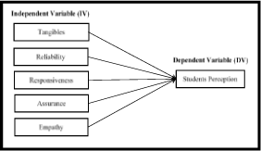

**Figure 1.** Framework of Study

# LITERATURE REVIEW

These dimensions consist of 1). Tangibles: This element refers to everything tangible and affects the quality of service to customers. For example, clean and tidy customer waiting rooms, facilities for customers, physical staff and employee, room ambiance, decoration, interior, etc. 2). Reliability: This element refers to the company's ability to provide services accurately to its customers. At this stage, the company's products and services can be accessed by customers anytime and anywhere. The company offers itself at all times to customers. For example, cellular operator companies provide signals in various areas where their customers are located. 3). Responsiveness: This element refers to the company's actions in responding to customers promptly. This level of responsiveness can be tested with questions, such as how much the company's curiosity is at the level of difficulty experienced by its customers, how capable the companies to help customers get out of the problem, how responsive the company is to complaints and customer complaints, and so on. 4). Assurance: This element refers to the company's ability to foster trust in the customer's eyes through the friendliness and knowledge of the staff in service. 5). Empathy: This element refers to the company's attention to its customers. The practice of corporate understanding can be realized by listening to customers, helping customers find solutions, understanding what becomes

anxieties and anxieties of customers, solidarity with customers, not leaving customers, etc.

Tangibles help evaluate the physical aspects of the service that contribute to overall customer satisfaction (Parasuraman et al., 1988). Yang and Fang (2004) provides a comprehensive view of the dimension of reliability within the context of service quality such as accurate order fulfillment, accurate record keeping, accurate quotes, accurate billing, accurate calculation of commissions and promise keeping. Imtiazi (2000) perspective highlights the multifaceted nature of zakat management, emphasizing the need for individuals and organizations to possess trustworthiness, qualifications, and relevant skills. This approach contributes to the responsible and ethical administration of zakat funds, ensuring that they fulfill their intended purpose of assisting those in need and promoting social justice in Islam.

Reichheld and Sasser (2010), suggests that responsiveness concept has been discussed in the context of customer service or business management literature. It underscores the importance of responsiveness as a fundamental component of delivering excellent customer experiences and fostering customer loyalty. Companies that prioritize responsiveness tend to build stronger customer relationships and are better positioned to retain customers and gain positive word-of-mouth referrals. Ultimately, responsiveness contributes to overall customer satisfaction and the success of a business or organization.

Donnelly, Wisniewski, Dalrymple & Curry (2014), suggests that assurance concept has been discussed in the literature related to business and service management. Assurance is a crucial component of building and maintaining trust with customers. When customers feel assured that an organization is committed to providing credible, secure, and high- quality services, they are more likely to have confidence in the organization and continue their patronage. In various industries, assurance efforts may also be subject to regulations and standards that require organizations to meet specific criteria for the protection and well-being of customers. According to Shahir and Adibah (2010), zakat institutions often operate within specific legal and regulatory frameworks in different countries. These frameworks may vary, but the core principles of zakat, including its religious significance and commitment to helping the less fortunate, are shared among Muslims worldwide. Therefore, ensuring that zakat institutions respect and honor these principles is central to their mission and effectiveness.

Donnelly et al. (2014), suggests that the concept of empathy in customer service may have been discussed in the context of business or service management literature. Empathy is a key element of providing excellent customer experiences and is often emphasized as a best practice in customer service training and service quality improvement efforts. It can lead to increased customer satisfaction and loyalty, as well as positive word-of-mouth recommendations, which are valuable for any organization.

# RESEARCH METHOD

## Research Design

A descriptive research design was employed in this study, by using the quantitative approach. This approval was used to collect data regarding five independent variables that were tangibles, reliability, responsiveness, assurance and empathy. The dependent variables of this study were student’s perception. Furthermore, the questionnaire was used once for carried out the data collection. A total of 255 students who receiving zakat

were chosen as population and as sample of study. This study used an existing instrument adapted from Siti Hawa Radin Eksan and Afizan Amer (2016).

## Population and Sample

The population of this study was students from all department in PUO consists of 255 students who receiving zakat in session December 2021 until June 2023 where the data obtained from secretary of Tabung Amanah Zakat, PUO. The researchers will choose all the respondent in the population as a sample of this study because the population are not large enough to be allocated for field work. The researchers had chosen those students who received zakat because they have experienced in receiving zakat and also aware on applying zakat.

Hairunnizam and Radiah (2010), said that the *amil* and the recipients of zakat play a crucial role in upholding the zakat system's principles of charity and social support, ensuring that it remains a fundamental aspect of Islamic practice and social justice.

Sampling technique that will be using in this research is convenience sampling because it is a type of non-probability sampling method where the sample is taken from a group of people easy to contact or to reach (Sekaran, 2003). This technique is easier rather than another technique. Other than that, it allows the researchers to gain the data about this study without any complication. The data that will be collected also easy to measure and more convenience.

## Research Instrument

The construction of the instrument is taking into consideration few aspects such as does not contain two different elements in order to avoid confusion to the respondent, easy to understand through the use of simple terms and short sentences, not prejudice to avoid insulting reactions or sensitive, respondent is competent in answering the questionnaire and can answer in a short period of time to avoid boredom among respondent. A student’s survey questionnaire was utilized as the primary research instrument for this study. The questionnaires for this study consisted of 35 items in three parts that were Part A, Part B and Part C.

Part A was about respondent’s demographic profile consisted of four items regarding their gender, semester, department, session receive zakat and how the respondents obtain information zakat distribution. Part B measured the dependent variable (DV) that is student’s perception and part C measured the independent variables (IV) that are tangibles, reliability, responsiveness, assurance and empathy.

The instruments were relied on a five (5) Likert scale which using rating scale. According to Dawes (2008), with a five-point scale, it is quite easy for the interview to read out the complete list of scale description and also easy to analyze the data. The scale was “1- strongly disagree”, “2-disagree”, “3-neither agree or disagree”, “4-agree”, “5-strongly agree”. The respondents were constructed to response based on the scales provided. However, for the sake of clarity, the researchers adapted rules of thumb proposed by Duru (2006). Mean scores of 1.49 or less were interpreted as strongly disagree, mean scores of 1.50-2.49 were interpreted as disagree, mean scores of 2.50-3.49 were interpreted as neither agree or disagree, mean scores of 3.50-4.49 were interpreted as agree and mean scores of 4.50 and above were interpreted as strongly agree on the survey items.

## Method of Data Collection

Data was collected from two types of data which are primary and secondary data. Primary data is the data will be collected from journals and web pages. Data that are collect from this method will relate in this research. This can help researcher to better define the problem and easily interpret the primary data. Secondary data is the data that had been collected by using the survey (manual). The questionnaire will be typed in English which then printed and stapled into booklet. Then, questionnaire had been directly given to the students in PUO which in 255 sample of students. The researcher will contact them by phone number and make an appointment to handout the form. Data will be collected by that day. The recipient will be given 10-15 minutes to answer the form. Time to collect the data is within 2 weeks start from Monday (05/09/2022) until Friday (16/09/2022). The questionnaire will be counted to ensure that the form is sufficient and proceed to process.

## Method of Data Analysis

Data analysis was the process to summarize and compare the data by using statistical tools (Sarantakos, 2007). After the respondents complete the questionnaire, the researcher had rechecked the survey to detect any mistake or incomplete answer. Then, all the data had been analyzed by using the Statistical Package Social Science (SPSS) software program version 22.0. The method that suitable for this research was Descriptive Statistic Analysis. The data that had been received from lecturer survey is quantitatively and had been analyzed by using mean, percentage, cross tabulation and chart. In doing this, the Correlation Analysis had been used as statistical tool to study the closeness of the relationship between two or more variables. The Pearson correlation coefficient, r, can take a range of values from +1 (+ve relationship) to -1 (-ve relationship). A correlation of 0.00 indicates no relationship, 0.00-0.49 indicates weak relationship, 0.50–0.79 indicates medium relationship, 0.80–0.99 indicates strong relationship and 1 indicates perfect relationship between two variables. In determine the strength of the relationship; this research used the guideline proposed by Hatcher (2003).

# RESULTS

## Respondent’s Profile

Table 1 showed the profile of the respondents under study. The results showed that about 56.5 percent of the participants were male and the rest of 43.5 percent were female. The highest number of respondents are from semester 4 which is 147 students. As for departments, JKM showed the highest amount number of samples which were 78 with a percentage of 30.6. Jun 2023 session indicated the highest percentage among other session which is 34.9. On how the applicants obtained the information, most of them received it from an announcement made by Academic Advisor (PA) that showed 41.6%.

**Table 1.** Respondents’ Profile

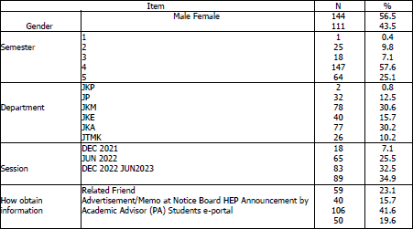

**Table 2.** Crosstabulation

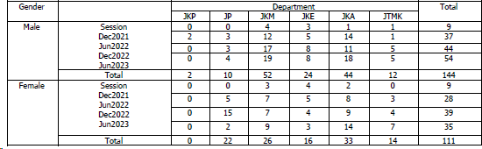

## Reliability Analysis

According to Hair et. Al (2014), a descriptive research must have a Cronbach Alpha greater than 0.6 and lower that 0.9 is generally considerate reliable. The value ranged from in conclusion the results conclude that the measurement scales of the variables were stable to measure the variables under study.

**Table 3.** Reliability Coefficient

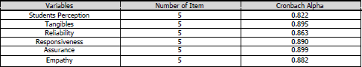

Table 3 above shows the reliability coefficient of variables under study. Students perception use domain constituted of 5 items with Cronbach Alpha 0.822, tangibles domain represented 5 items with alpha value 0.895, reliability domain represented 5 items with alpha value 0.863, responsiveness domain represented 5 items with alpha value 0.890, assurance domain represented 5 items with alpha value 0.899 and empathy domain represented 5 items with alpha value 0.882.

## Descriptive Analysis

Descriptive analysis for 255 respondents was obtained from questionnaire based on mean of the main research variables. The intention is to answer the six main research questions. The results of the analysis were presented in the sub-section below:

### *Students Perception*

Analysis on student’s perception was presented on Table 4. The table showed that majority of the students perceived agree on perception on zakat distribution with overall mean 4.2840. Analysis was then continued on analysis by item for each of the variables. The following observations were made. There was an agreement on item SP8 and SP10. Item SP10 (Zakat management should continue assisting student financial problems) had the highest mean score with the value 4.53. It showed that the respondents strongly agreed with the item with the frequency of 137 (53.7%); only 0.4 percent who neither agree or neither disagree with this item. Item SP8 had the second highest mean score with the value of 4.30. There were 83 (32.5%) respondents strongly agreed with the statement. In addition, the highest mean score was shown on item SP10 (4.53), followed by SP8 (4.30), SP6 (4.26), SP9 (4.24) and the lowest mean is SP7 (4.09). The conclusion is the majority of the respondents are agreed with aspect of student’s perception towards zakat distribution.

**Table 4.** Analysis by Item on Students Perception

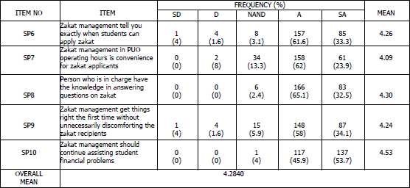

### *Tangibles*

Analysis on tangibles was presented on Table 5. The table showed that majority of the students perceived agree on perception on zakat distribution with overall mean 4.0980. Analysis was then continued on analysis by item for each of the variables. The following observations were made. There was an agreement on item T11 and T13. Item T11 (Person who is in charge of zakat distribution appears neat) had the highest mean score with the value 4.15. It showed that the respondents agreed with the item with the frequency of 193 (75.7); only 0.4 percent do not agree with this item. Item T13 (I feel comfortable with the surrounding of the office) had the second highest mean score with the value of 4.14. There were 179 (70.2%) respondents agreed with the statement. In addition, the highest mean score was shown on item T11 (4.15), followed by T13 (4.14), T14 (4.11), T15 (4.11) and the lowest mean is T12 (3.98). The conclusion is the majority

of the respondents are agreed with aspect of tangibles of student’s perception towards zakat distribution.

**Table 5.** Analysis by Item on Tangibles

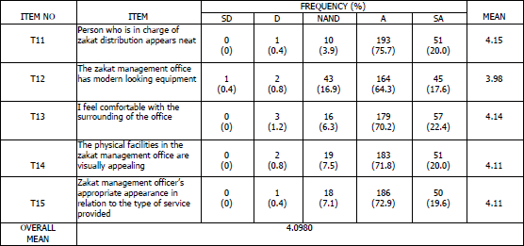

### *Reliability*

Analysis on reliability was presented on Table 6. The table showed that majority of the students perceived agree on perception on zakat distribution with overall mean 43080. Analysis was then continued on analysis by item for each of the variables. The following observations were made. There was an agreement on item R20 and R16. Item R20 (I feel safe in dealing with zakat management) had the highest mean score with the value

4.40. It showed that the respondents agreed with the item with the frequency of 142 (55.7%); only 0.4 percent do not agree with this item. Item R16 (Zakat recipients can fully depend or rely on zakat management) had the second highest mean score with the value of 4.37. There were 140 (54.9%) respondents agreed with the statement. In addition, the highest mean score was shown on item R20 (4.40), followed by R16 (4.37) R18 (4.25), R19 (4.25) and the lowest mean is R17(4.18). The conclusion is the majority of the respondents are agreed with aspect of reliability of student’s perception towards zakat distribution.

**Table 6.** Analysis by Item on Reliability

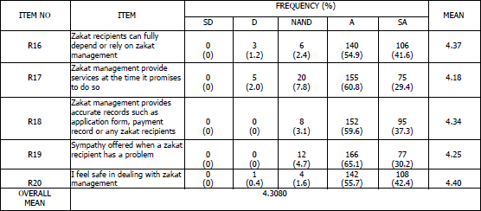

### *Responsiveness*

Analysis on responsiveness was presented on Table 7. The table showed that majority of the students perceived agree on perception on zakat distribution with overall mean 4.2100. Analysis was then continued on analysis by item for each of the variables. The following observations were made. There was an agreement on item RP21 and RP25. Item R25 (Zakat management will never be too busy to respond to zakat recipient) had the highest mean score with the value 4.37. It showed that the respondents agreed with the item with the frequency of 154 (60.4%); only 1.2 percent who neither agree or neither disagree with this item. Item RP21 (Employee in zakat management telling zakat recipients exactly when services will be performed) had the second highest mean score with the value of 4.21. There were 147 (57.6%) respondents agreed with the statement. In addition, the highest mean score was shown on item RP25 (4.37), followed by RP21 (4.21), RP23 (4.19), RP22 (4.16) and the lowest mean is RP24 (4.12). The conclusion is the majority of the respondents are agreed with aspect of responsiveness of student’s perception towards zakat distribution.

**Table 7.** Analysis by Item on Responsiveness

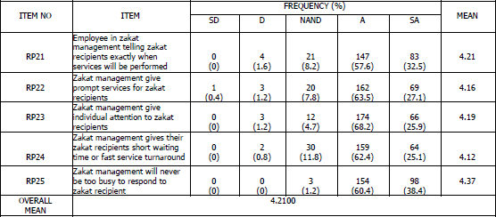

### *Assurance*

Analysis on assurance was presented on Table 8. The table showed that majority of the students perceived agree on perception on zakat distribution with overall mean 4.2820. Analysis was then continued on analysis by item for each of the variables. The following observations were made. There was an agreement on item A26 and A27. Item A26 (Person in charge in zakat management are trustworthy and honest) had the highest mean score with the value 4.35. It showed that the respondents agreed with the item with the frequency of 162 (63.5%); only 0.8 percent who neither agree or neither disagree with this item. Item A27 (The behavior of person in charge in zakat management is confidence to their zakat recipients) had the second highest mean score with the value of 4.32. There were 172 (67.5%) respondents agreed with the statement. In addition, the highest mean score was shown on item A26 (4.35), followed by A27 (4.32), A28 (4.26), A30 (4.26) and the lowest mean is A29 (4.22). The conclusion is the majority of the respondents are agreed with aspect of assurance of student’s perception towards zakat distribution.

**Table 8.** Analysis by Item on Assurance

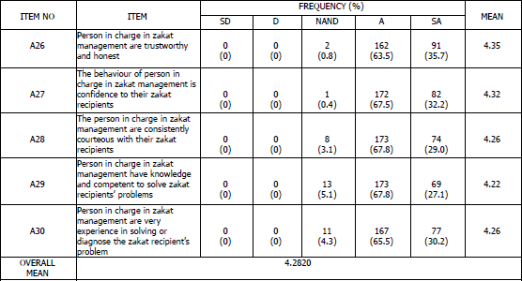

### *Empathy*

Analysis on empathy was presented on Table 9. The table showed that majority of the students perceived agree on perception on zakat distribution with overall mean 4.3040. Analysis was then continued on analysis by item for each of the variables. The following observations were made. There was an agreement on item E32 and E34. Item E34 (Zakat management communicates well the recipients) had the highest mean score with the value 4.38. It showed that the respondents agreed with the item with the frequency of 153 (60.0%); only 1.2 percent who neither agree or neither disagree with this item. Item E32 (Zakat management willing to help zakat recipients) had the second highest mean score with the value of 4.36. There were 160 (62.7%) respondents agreed with the statement. In addition, the highest mean score was shown on item E34 (4.38), followed by E32 (4.36), E33 (4.36), E31 (4.27) and the lowest mean is E35 (4.15). The conclusion is the majority of the respondents are agreed with aspect of empathy of student’s perception towards zakat distribution.

**Table 9.** Analysis by Item on Empathy

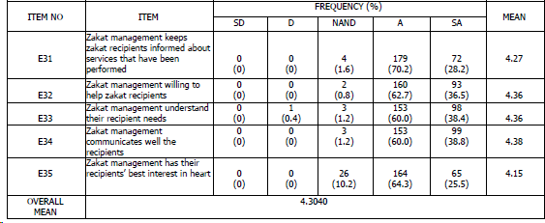

## Correlation Analysis

The correlation analysis between independent variables and dependent variables under study had been done to examine whether the purpose independent variables were correlate with dependent variables. This was important for the researchers to determine that the independent variables were related with each other’s to the student perception towards services quality of zakat distribution in PUO. The correlation analysis was shown on Table 10. In determining the strength of the relationship, this study used the guideline proposed by Hatcher (2003). The result of the correlation analysis showed that all those five independent variables under study correlated significant with each other. The correlation between tangibles showed a result of medium +ve correlation with r=.590, n=255, p=.000 followed by the correlation between empathy showed a result of medium

+ve correlation with r=.686, n=255, p=.000. The correlation between assurance showed a result of medium +ve correlation with r=.712, n=255, p=.000. Next, the correlation between student’s perception and reliability showed a result a medium +ve correlation with r=.718, n=255, p=.000. Lastly, responsiveness showed a result of medium +ve correlation with r=.738, n=255, p=.000. This shown that increasingly tangibles, empathy, assurance and reliability will increase student’s perception towards services quality of zakat distribution in PUO.

**Table 10.** Correlation

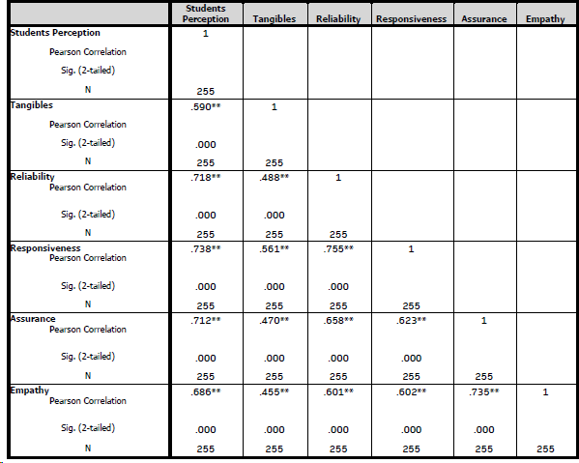

# DISCUSSION

Based on the result from descriptive analysis, it showed that the highest mean score was reliability with 4.3080. Majority of the respondent agree and believe that reliability can influence student’s perception towards services quality of zakat distribution. According to Yang and Fang (2004), provides a comprehensive view of the dimension of reliability within the context of service quality such as accurate order fulfillment, accurate record keeping, accurate quotes, accurate billing, accurate calculation of commissions and promise keeping.

Based on the finding, it found that all the independent variables have positive significant with student’s perception towards services quality of zakat distribution. The highest correlation was responsiveness with 0.738. According to Reichheld and Sasser (2010), the importance of responsiveness as a fundamental component of delivering excellent customer experiences and fostering customer loyalty. Companies that prioritize responsiveness tend to build stronger customer relationships and are better positioned to retain customers and gain positive word-of-mouth referrals.

There are several recommendations for education institution and researchers in future action to the improvement of zakat management. Firstly, education institution needs to simplify and streamline the zakat distribution procedures to make the process more efficient. Consider digital solutions for form submission and qualification assessment to reduce paperwork and manual tasks. Secondly, education institution needs to hire more staff members or designate additional resources to assist with zakat distribution. If possible, assign dedicated personnel for zakat management to alleviate the burden on lecturers. Thirdly, education institution needs to recognize the importance of zakat distribution and allocate dedicated time for the staff member responsible for this task. Ensure that staff members managing zakat are not overwhelmed with other responsibilities. Fourthly, education institution needs to implement a digital platform or software to manage the zakat distribution process more efficiently. This can include online application forms, automated qualification assessment, and tracking systems. Lastly, education institution needs to provide training and awareness programs to staff and students regarding the importance of zakat and the zakat distribution process. Encourage collaboration and support from the university community.

Meanwhile, for further research need to expand the number of respondents and including more education institutions in order to know more results about zakat perception among students.

# CONCLUSION

To summarize, by implement all the recommendation given, PUO can enhance the effectiveness and efficiency of its zakat distribution process, ensuring that the zakat reaches the deserving recipients in a timely manner while reducing the burden on staff members. Thus, students will feel trust and relying solely on the institution.

# REFERENCES

Ahmad Shahir, M. & Adibah, A. B. (2010). Administration of Zakat in Selangor State: Issues and Challenges. National Convention Proceedings on Development and Administration of Wealth in Islam 2010. *Shari’ah* Department, Faculty of Islamic Studies, UKM.

Azman, A. R., Mohammad, A., and Syed Mohd Najib, S. O. (2012). Zakat institution in Malaysia: Problems and issues. Gjat, 2(1), 35–41. Retrieved from <http://www.gjat.my/gjat062012/gjat1220120201.pdf>.

Azura, M. N. and Saad, R. A. J. (2016). The Mediating Effect of Trust on the Relationship between Attitude and Perceived Service Quality towards Compliance Behavior of *Zakah*, International Journal of Economics and Financial Issues, 6(S7), 27-31.

BERNAMA. (2017, March 26). 3,000 places for outstanding students failed to continue their studies at UiTM. Utusan Online. Retrieved from [http://www.utusan.com.my/mobile/berita/nasional/3-000-tempat-untuk-pelajar-](http://www.utusan.com.my/mobile/berita/nasional/3-000-tempat-untuk-pelajar-cemerlanggagal-lanjut-pelajaran-di-uitm-1.462068) [cemerlanggagal-lanjut-pelajaran-di-uitm-1.462068](http://www.utusan.com.my/mobile/berita/nasional/3-000-tempat-untuk-pelajar-cemerlanggagal-lanjut-pelajaran-di-uitm-1.462068).

Dawes, J. (2008). Do data characteristics change according to the number of scale points used? An experiment using 5-point, 7-point and 10-point scales. International Journal of Market Research, 50(1). <https://doi.org/10.1177/147078530805000106>.

Donnelly, Wisniewski, Dalrymple & Curry (2014). Measuring service quality in local government the SERVQUAL approach, International Journal of Public Sector Management.

Duru, S. (2006), Pre-Service Elementary Education Teacher’s Beliefs About Teaching And Learning In Turkey, Ph.D Dissertation. Indiana University.

Hair, J. F., Hult, G. T. M., Ringle, C. M., & Sarstedt, M. (2014). A Primer on Partial Least Squares Structural Equation Modeling (PLS-SEM). (A. Hutchinsm & V. Knight, Eds.) (First Edit). Wasington DC: SAGE Publications, Inc.

Hairi, M.D., Hussain, M.D. (2009). Keberkesanan Sistem Agihan Zakat: Suatu Pandangan Awal. In The 4th ISDEV International Graduate Workshop (INGRAW 2009). p1-14.

Hairunnizam, Sanep & Radiah (2010). Understanding *Asnaf* Attitude: Malaysia’s Experience in Quest for An Effective Zakat Distribution Programme.

Hairunnizam, W., Radiah, A.K., Sanep, A. (2012). Penerimaan *amil* dan *asnaf* terhadap penyetempatan pengagihan zakat di Malaysia. Jurnal Ekonomi Malaysia, 46(1), 39-51.

Hamid, N. H. (2017, August 12). KPTM offer 3,000 places for dropout stundets. Sinar Harian. Retrieved from <http://www.sinarharian.com.my/mobile/nasional/kptm-> tawar-3-000-tempatuntuk-pelajar-tercicir-1.717794.

Hatcher, L, (2003), Step-By-Step Basic Statistics Using SAS: Student Guide, SAS Institute Inc. Cary, NC, USA.

Imtiazi (2000). Management of *Zakah* in Modern Muslim Society.

Parasuraman et al. (1988). A Conceptual Model of Service Quality and Its Implications for “Future Research Journal of Marketing. vol. 49 (Fall 1985).

Raudha, M.R., Sanep, A., Hairunnizam, W., Abdul, G.I., Nik, S.N.S., Norzaihawati, Z. (2011). Indeks Keyakinan Pembayar Zakat Terhadap Keupayaan Pengurusan

Dana Zakat: Kajian Kes di Lembaga Zakat Selangor (LZS). In: Zakat Conference, 2011.

Reichheld and Sasser, W.E. (2010). Zero Defections: Quality Comes to Services.

Harvard Business, Review, Sept.-Oct, p. 105-111.

Sanep, A., Hairunnizam, W. (2005b). Persepsi agihan zakat dan kesannya terhadap pembayaran zakat melalui institusi formal. Jurnal Ekonomi Malaysia, 39, 53-69. Available from: <http://www.ukm.my/penerbit/> jurnal_pdf/JEM39-03.pdf.

Sarantakos, S. (2007) Data Analysis. Vol. 1-4, Sage Publications, Thousand Oaks. Sekaran, U. (2003). Research Methods for Business: A Skill-building Approach.

Singapore: John Wiley & Sons.

Siti Hawa Radin Eksan and Afizan Amer (2016). Assesment of Quality Service for Zakat Receipent Among *Asnaf Mualaf* in Zakat Institution. Journal of Business Innovation, Jilid 2 2016: 11-20.

Sulaiman, H., & Jamil, N. (2015). Information Security Governance Model to Enhance Zakat Information Management in Malaysian Zakat institutions. Conference Proceedings - 6th International Conference on Information Technology and Multimedia at UNITEN: Cultivating Creativity and Enabling Technology Through the Internet of Things, ICIMU 2014, 200–205.

Yang and Fang (2004). Online Service Quality Dimensions and Their Relationships with Satisfaction: A Content Analysis of Customer Reviews of Securities Brokerage Services, International Journal of Service Industry Management.

Zainal, H., Abu Bakar, A. and Saad, R. A. J. (2016). Reputation, Satisfaction of Zakat Distribution, and Service Quality as Determinant of Stakeholder Trust in Zakat Institutions, International Journal of Economics and Financial Issues, 6(S7), 72- 76.