The Influence of Social Media and Customer Trust on Decisions to Use Bridal Beauty Queen Services

Vanessa ^{1,} Sri Rezeki ²
STIE Eka Prasetya¹, Universitas Negeri Medan²
Jl. Merapi No.8, Pusat Pasar, Kec.Medan Kota, Kota Medan, Sumatera Utara, 20212, Indonesia
Vanessazhuo03@gmail.com

ABSTRACT

This study aims to determine the Effect of Social Media and Customer Trust on the Decision to Use Bridal Beauty Queen Services. The research methodology used is quantitative descriptive method. The type of data used in this study is quantitative data, which is obtained in the form of numbers and numbers. Data sources are primary and secondary data. The population used is all customers who purchase services at Bridal Beauty Queen, totaling 78 people. From the population, selected with saturated sampling technique which means that the entire population becomes the research sample. The analysis method used is multiple linear regression with the regression equation User Decision = 4.547 + 0.559 Social Media + 0.201 Customer Trust. The results of the research analysis show that Social Media has a significant positive effect on Bridal Beauty Queen User Decisions and Customer Trust has a positive and significant effect on Bridal Beauty Queen User Decisions. Simultaneously Social Media and Customer Trust simultaneously have a significant and significant effect on the User Decision of Bridal Beauty Queen Services with the Adjusted R Square result of 0.672. This shows that 67.2% of the Bridal Beauty Queen Service User Decision is influenced by the Social Media and Customer Trust variables while the remaining 32.8% is influenced by other variables not examined in this study.

Keywords: Social Media, Customer Trust, Usage Decision, Bridal Beauty Queen, Customer

INTRODUCTION

At this time, almost every day there will be a new couple to get married where marriage is one of the life goals of almost all people today. Marriage is also something sacred and is also one of the obligations of mankind to be able to continue to develop so that the human ecosystem on earth can be maintained. Bridal is one of the service providers engaged in wedding needs. Bridal currently provides clothing to bridal makeup to carry out the wedding procession. Bridal is also one of the first destinations for couples who will carry out the wedding because Bridal provides wedding clothes both from wedding dresses and suits to the traditional clothes of the bride and groom. Apart from wear, Bridal also provides other needs of the bride and groom where bridal provides makeup services to the bride and groom and also the family of the bride and groom. Bridal also provides accessories, bridal flowers to the car makeup of the bride so that this makes bridal one of the main destinations for prospective brides.

Medan city also has a lot of bridal where one of them is Beauty Queen. Beauty Queen is one of the bridal that has been established since 2019. Beauty Queen was founded by Mrs. Ira, where initially Mrs. Ira was one of the photographers in the city of Medan and was widely recognized by the people in the city of Medan. But over time, Mrs. Ira established a bridal in order to increase his business and also facilitate his work. Currently Beauty Queen already has a lot of customers who have used the services of Beauty Queen to be part of the bride's wedding. However, Beauty Queen is currently experiencing a decline in sales where the decline in sales from Beauty Queen is caused by the decline in consumer decisions to use the services of Beauty Queen. There are several factors that cause the decline in the decision to use Beauty Queen bridal services, one of which is the lack of utilization of social media from Beauty Queen bridal.

Social Media is a communication and marketing tool that allows users to interact, share, and exchange information and ideas in a virtual network. Social media is part of internet development that allows users to disseminate information or content anytime and anywhere. The existence of social media will certainly be able to facilitate its users where social media provides a lot of information so that it will provide convenience in finding the information needed. In addition, social media is also one of the suggestions in developing businesses from business people where business people can advertise goods to be offered to consumers and consumers can find what these consumers need so that it can also be stated that social media can be a forum for buying and selling transactions.

Social Media from Beauty Queen is still considered less than optimal use where Beauty Queen is still relatively few in uploading photos of the clothes or make-up results from the Bridal. In addition, the results of photos from the bridal are still relatively poor so that they cannot increase the interest or interest of potential users of their services. The use of social media to promote bridal is also still relatively little done where Bridal Beauty Queen rarely uses ads to introduce bridal to potential customers. So that it makes consumers less familiar with Bridal Beauty Queen so that it reduces consumer interest in using its services.

In addition, consumer trust can also have an impact on decisions to use services where the high trust of consumers will make consumers more confident to use the services offered to them. On the other hand, if consumers have low trust in the product or service, it will make consumers switch to choosing another product or service that is considered more convincing. Therefore, every business actor needs to increase the trust that consumers have. Business actors will do various ways to be able to convince consumers of the products or services offered by them. However, the trust that consumers have in Bridal Beauty Queen is quite low, which is because Bridal still has few customers and also Bridal rarely conducts exhibitions so that it makes the level of consumer confidence low in Bridal Beauty Queen.

LITERATURE REVIEW

Purchasing Decision
According Aripin & Negara (2021:53), Purchasing Decision is a process of how to determine the best, logical, rational, and ideal decision based on facts, data and information from an alternative to achieve the goals set with little risk, effectively, and efficiently.
A purchasing decision, according to M. Anang Firmansyah (2018), is the process of generating a number of different courses of action before selecting one to buy.
According to Siatama et al. (2023), a consumer's purchasing decisions are just one step in a sequence of mental and physical actions that take place during the purchase process at specific times and to satisfy specific demands.
Consumer decision-making, according to Sinaga (2021), is an integration process that integrates knowledge to assess two or more alternative actions and select one.
According Wangsa (2019:13), Indicators of purchasing decisions used in research are as follows Stability in a product, Habit of buying products, Willingness to recommend, Interest in visiting again.
From the theory above it can be concluded that Purchasing decisions are a continuum consisting of 2 dimensions, namely dimensions that indicate the involvement of consumers in purchasing decisions and dimensions that indicate the amount of information consumers need to be able to make decisions by searching for information and considering various alternatives.

Social Media
According (Abdul Rauf et al., 2021) Social media is a medium used to socialize everyone online or online without being limited by time and space.
According (Agustianto et al., 2023), The internet-based technology known as social media makes it easier for users to communicate and engage with one another.
Several indications are found in social media, according to (Indriyani & Suri, 2020). information that is both fascinating and enjoyable, exchanges between buyers and sellers, Consumers' interactions with one another, Finding product information is simple. Facilitation of public information dissemination, Social media trust level
According to the aforementioned notion, social media is a digital platform that enables online interaction, sharing, and content creation. A component of the internet's growth, social media enables people to engage in social activities without being constrained by time or location.

Consumer Trust
According (Todingbua, 2022), Consumer Trust is the belief that customers have in the company because the company can provide the expectations they want and need (needs and wants).
According (Astuti & Amanda, 2020), Consumer trust is consumer knowledge about an object, its attributes, and its benefits.
According (Donni Juni Priansa, 2017), stated that research conducted for more than 40 years on trust, has resulted in dimensions that can be used as instruments for measuring trust, namely satisfaction, interpersonal scale, trustworthiness,

From the theory above it can be concluded that Customer trust is a consumer's confidence in a company, product, or service. Customer trust can be defined as the belief that a company will fulfill its promises and do the right thing for customers

RESEARCH METHOD

Bridal Beauty Queen, located at Jalan Ladang No. 187 Medan, is the site of this study. This kind of research is quantitative and employs a survey approach, using a questionnaire as a research tool to gather primary data (Manik et al., 2022). Quantitative data is what this kind of research data is. According to Opinion Sugiyono (2019:9), this kind of study is survey-based and quantitative, using a questionnaire as a research tool to gather primary data. Quantitative data is what this kind of research data is. According to Based on Opinion (Sugiyono, 2020), a population is a category for generalization made up of items or people with specific attributes chosen by researchers for analysis before conclusions are made. In this study, the population is all Bridal Beauty Queen customers in 2024, totaling 79 people.

According to Sugiyono's (2020) perspective, The sample is a component of the population's size and makeup. Saturated sampling was the sample strategy employed in this investigation. As a result, 79 regular consumers served as research samples. According to the viewpoint (Sugiyono, 2020), data can be gathered by documentation, questionnaires, interviews, observation, and a combination of the four methods.

RESULTS

Validity Test Results
Table 1 Validity Test Results

Questioner | Social Media (X1) |  |  | Customer Trust(X2) |  |  | Customer Use (Y)
Questioner | Pearson Correlation | Sig | Pearson Correlation |  | Sig | Pearson Correlation |  | Sig
1 | 0.452 | 0.012 | 0.821 |  | 0.000 | 0.452 |  | 0.012
2 | 0.664 | 0.000 | 0.522 |  | 0.003 | 0.664 |  | 0.000
3 | 0.508 | 0.004 | 0.587 |  | 0.001 | 0.508 |  | 0.004
4 | 0.498 | 0.005 | 0.715 |  | 0.000 | 0.498 |  | 0.005
5 | 0.545 | 0.002 | 0.466 |  | 0.010 | 0.545 |  | 0.002
6 | 0.551 | 0.002 | 0.668 |  | 0.000 | 0.551 |  | 0.002
7 | 0.513 | 0.004 | 0.742 |  | 0.000 | 0.513 |  | 0.004
8 | 0.720 | 0.000 | 0.475 |  | 0.008 | 0.720 |  | 0.000
9 |  |  | 0.801 |  | 0.000
10 |  |  | 0.863 |  | 0.000
11 |  |  | 0.715 |  | 0.000
12 |  |  | 0.484 |  | 0.007
Source: SPSS Testing Results, 2024

Based on table 1, the results of testing the instrument questionnaires of all variables are above 0.361 and are significant not exceeding 0.05. so that all questions from all variables used are valid..

Reliability Test
Table 2 Reliability Test Results

Variables | Cronbach's Alpha | N of Items
Social Media | 0.667 | 8
Customer Trust | 0.880 | 12
Customer Decision | 0.667 | 8
Source: SPSS Testing Results, 2024

Based on table 2, the reliability value of each instrument of all variables is above 0.60 so that it can be stated that all variables are reliable.

Descriptive Statistics Analysis
Table 3 Descriptive Statistics Test Results

Descriptive Statistics
 | N | Minimum | Maximum | Mean | Std. Deviation
Social_Media | 78 | 14.00 | 31.00 | 23.7564 | 3.84500
Customer_Trust | 78 | 26.00 | 47.00 | 37.0256 | 4.70969
User_Decision | 78 | 17.00 | 32.00 | 25.2564 | 3.48815
Valid N (listwise) | 78
Source: SPSS Testing Results, 2024

The Social Media variable has a minimum value of 14 and a maximum value of 31, with an average of 23.7564 and a standard deviation of 3.84500. Table 3 shows that 78 Bridal Beauty Queen consumers make up the data set. With an average of 37.0256 and a standard deviation of 4.70969, the Customer Trust variable ranges from a minimum of 26 to a maximum of 47. The User Decision variable's average value is 25.2564, its standard deviation is 3.48815, and its minimum and maximum values are 17 and 32, respectively.

Classical Assumption Test
Normality Test
Figure 1. Normality Test Results with Histogram Graphs
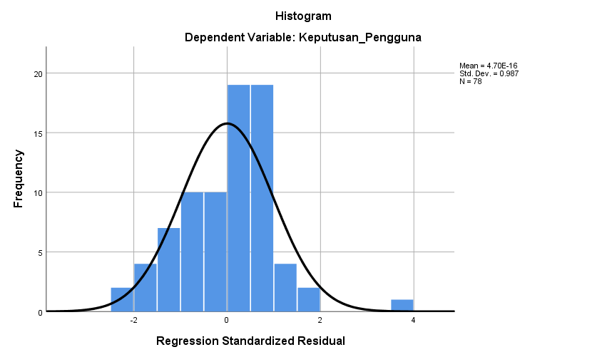
Source: SPSS Testing Results, 2024

Figure 1 indicates that the data is regularly distributed since the histogram test's diagonal line is shaped like a bell diagram and does not run to the left or right.

Figure 2. Normality Test Results with Probability Plot Method

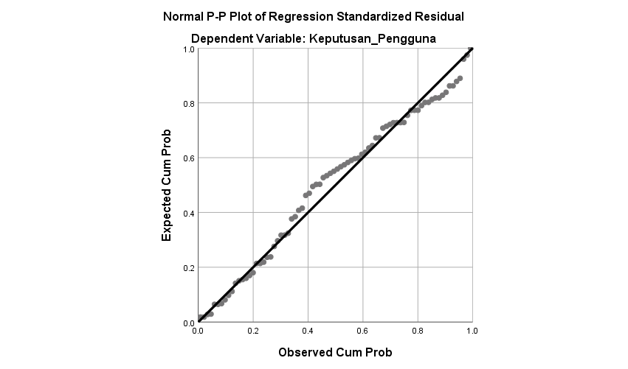
Source: SPSS Testing Results, 2024

Figure 2 shows the distribution of points around the diagonal line and does not deviate to the left or right so that it can be stated that the data is normal.

Table 3 Normality Test Results One-Sample Kolmogrocv-Smirnov Test
One-Sample Kolmogorov-Smirnov Test
 |  | Unstandardized Residual
N |  | 78
Normal Parameters^{a,b} | Mean | .0000000
Normal Parameters^{a,b} | Std. Deviation | 1.97180233
Most Extreme Differences | Absolute | .085
Most Extreme Differences | Positive | .071
Most Extreme Differences | Negative | -.085
Test Statistic |  | .085
Asymp. Sig. (2-tailed) |  | .200^{c,d}
a. Test distribution is Normal.
b. Calculated from data.
c. Lilliefors Significance Correction.
d. This is a lower bound of the true significance.
Source: SPSS Testing Results, 2024

Table 3 shows ithat ithe iKolmogrov iSmirnov ivalue iobtained ishows ia isignificant ivalue iof imore ithan i0.05, iwhich iis i0.2 iso ithat ithe iresearch idata iis ideclared inormally idistributed.

Multicollinearity Test
Table 4 Multicollinearity Test Results

Coefficientsª
Model |  | Collinearity Statistics
 |  | Tolerance | VIF
1 | (Constant)
1 | Social_Media | 0.536 | 1.865
1 | Customer_Trust | 0.536 | 1.865
a. Dependent Variable: User_Decision
Source: SPSS Testing Results, 2024

The itolerance ivalue iof iall ivariables iis iabove i0.10 iwhile ithe iVIF ivalue iof iall ivariables iis ibelow i10. iThus, ifrom ithe iMulticollinearity itest iresults, iit ican ibe iconcluded ithat ithere iis ino icorrelation ibetween ithe iindependent ivariables.

Heteroscedasticity Test
Figure 3 Heteroscedasticity Test Results
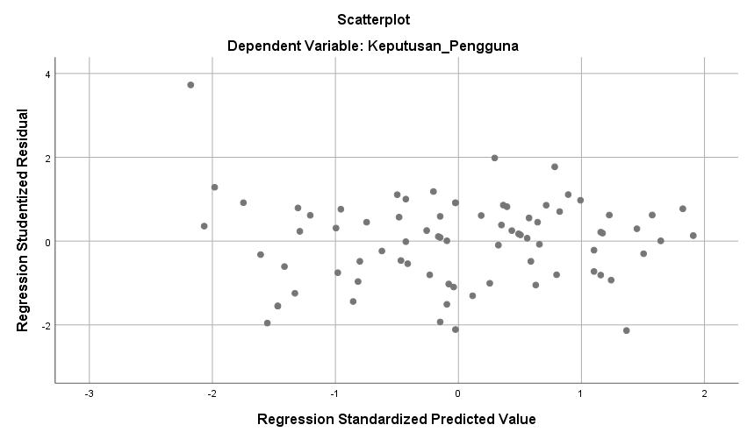
Source: SPSS Testing Results, 2024

In Figure 3, it ican ibe iseen ithat ithe ipoints iare irandom ior ido inot iform ia icertain ipattern ithat iis iclearly ithe ilargest iboth iabove iand ibelow ithe inumber i0 ion ithe iRegeression iStudentized iResidual i(Y) iaxis. iThis imeans ithat ithere iis ino iheteroscedacity iin ithe iregression imodel iso ithat ithis iregression imodel iis isuitable ifor ipredicting iUsage iDecisions ibased ion iSocial iMedia iand iCustomer iTrust.

Multiple Linear Regression Analysis
Table 5 Test Results of Multiple Linear Regression Analysis

Coefficientsª
Model |  | Unstandardized Coefficients |  | Standardized Coefficients
 |  | B | Std. Error | Beta
1 | (Constant) | 4.547 | 1.822
1 | Social_Media | 0.559 | 0.081 | 0.616
1 | Customer_Trust | 0.201 | 0.066 | 0.271
a. Dependent Variable: User_Decision
Source: SPSS Testing Results, 2024

User Decision = 4.547 + 0.559 Social Media + 0.201 Customer Trust

Table i5 iexplains ithat ithe iconstant ivalue ia iof i4.547 imeans ithat iif iall iindependent ivariables iare iconstant ior ihave ia ivalue iof i0, ithe iUser iDecision iis i4.547 iunits. iThe iSosail iMedia ivariable i(_{X1}) iof i0.559 istates ithat ievery iincrease iin iSocial iMedia iof i1 iunit iwill icause iUser iDecisions ito iincrease iby i0.559. iThe iCustomer iTrust iVariable i(_{X2}) iof i0.201 istates ithat ieach iincrease iin icustomer itrust iof i1 iunit iwill icause ian iincrease iin iUser iDecisions iby i0.201.

Partial Hypothesis Testing (t test)
Table 6 Partial Hypothesis Testing Results

Coefficientsª
Model |  | t | Sig.
1 | (Constant) | 2.495 | 0.015
1 | Social_Media | 6.913 | 0.000
1 | Customer_Trust | 3.040 | 0.003
a. Dependent Variable: User_Decision
Source: SPSS Testing Results, 2024

In itable i6 ithe iresults iof ivariable i_{X1} i(Social iMedia) _{tcount} i= i2.495, ithen ithe it itable iis iwith idf i= i75 isignificance ilevel i5% i(0.05) itwo-sided itest iis i1.99210. iBecause i6.913> i1.99210 iand isignificant i0.000 i<0.05, iSocial iMedia ihas ia isignificant ipositive ieffect ion iBridal iBeauty iQueen iUser iDecisions.

Variable_{X2 i( i}Customer iTrust) iobtained ia_{tcount} ivalue iof i3.040> i1.99210 iand ia isignificance ilevel iof i0.004 i<0.05. imeaning ithat iCustomer iTrust ihas ia ipositive iand isignificant ieffect ion iBridal iBeauty iQueen iUser iDecisions.

Simultaneous Hypothesis Testing (F Test)
Table 7 Simultaneous Hypothesis Testing Results

ANOVAª
Model |  | F | Sig.
1 | Regression | 79.853 | .000^{b}
1 | Residual
1 | Total
a. Dependent Variable: User_Decision
b. Predictors: (Constant), Customer_Trust, Social_Media
Source: SPSS Testing Results, 2024

In Table 7, it is known that the _{Fcount} value is 79.853 with a significant level of 0.000. For a confidence level of 95%, _{df1} = 3, and _{df2} = 75, the_{Ftable} value is 3.12. Because _{Fhitung> Ftabel}, the criterion is _{H3} Accepted so that it can be stated that Social Media and Customer Trust simultaneously have a significant effect on the Decision to Use Bridal Beauty Queen Services.

Test Coefficient of Determination (R²)
Table 7 Test Results of the Coefficient of Determination

Model Summary^{b}
Model | R | R Square | Adjusted R Square
1 | .825ª | 0.680 | 0.672
a. Predictors: (Constant), Customer_Trust, Social_Media
b. Dependent Variable: User_Decision
Source: SPSS Testing Results, 2024

Based ion itable i7 iabove, iit iis iknown ithat ithe iAdjusted iR iSquare icoefficient iof idetermination iused ito imeasure ihow ifar ithe imodel's iability ito iexplain ithe ivariation iin ithe idependent ivariable iis i0.672. iThis ishows ithat i67.2% iof ithe iBridal iBeauty iQueen iService iUser iDecision iis iinfluenced iby ithe iSocial iMedia iand iCustomer iTrust ivariables iwhile ithe iremaining i32.8% iis iinfluenced iby iother ivariables inot iexamined iin ithis istudy.

CONCLUSION

Based on the research results, it can be concluded that the Social Media Variable (X1) shows that there is a positive influence and also has a significant influence on User Decisions (Y) of Bridal Beauty Queen Services, This means that the existence of social media that is used appropriately and maximally will have an impact on the decisions of consumers in owning Bridal BeautyQueen to increase. The Customer Trust variable (X2) shows that there is a positive influence and also has a significant influence on User Decisions (Y) of Bridal Beauty Queen Services This means that the trust of consumers that is built continuously will make consumers more confident in using the services offered, which means that the decision of consumers to choose Bridal Beauty Queen will increase. The variables Social Media (X1) and Customer Trust (X2) simultaneously show that there is a significant influence on User Decisions (Y) of Bridal Beauty Queen Services, This means that the maximum use of social media can provide greater consumer confidence in the product so that it will make consumer decisions in choosing Bridal Beauty Queen increase.

REFERENCE

Abdul Rauf, Sardjana Orba Manullang, Tri Endi Ardiansyah, Farah Diba, Ilham Akbar, Robi Awaluddin, Puji Muniarty, Hamdan Firmansyah, Ahmad Mundzir, Vigory Gloriman Manalu, Genesis Sembiring Depari, & Elsy Rahajeng. (2021). Digital Merkating : Konsep dan Strategi (Pertama). Insania.
Agustianto, N. P., Andayani, S. U., Anwar, Sihombing, L., Setiawan, A., Amelia, D., Gunawan, C., Indraswati, T. D., & Nurbismi. (2023). Pengantar Bisnis (Respons Dinamika Era Digital) (Pertama). Seval Literindo Kreasi.
Aripin & Negara. (2021). PERILAKU BISNIS ETIKA BISNIS & PERILAKU KONSUMEN.
Astuti, M., & Amanda, A. R. (2020). PENGANTAR MANAJEMEN PEMASARAN. Deepublisher.
Donni Juni Priansa. (2017). Komunikasi Pemasaran Terpadu (Pertama). CV. Pustaka Setia.
Gunawan. (2022). KEPUTUSAN PEMBELIAN KONSUMEN MARKETPLACE SHOPEE BERBASIS SOCIAL MEDIA MARKETING.
Loo, P., Novilia, F., Raharjo, T. B., Semmawi, R., & Abas, A. J. (2024). The Influence Of Shopping Lifestyle On Impulse Buying Behavior With Positive Emotion As A Moderating Variable. INNOVATIVE: Journal Of Social Science Research, 4(1), 1526–1534.
Loo, P. (2024). Pengaruh Customer Bounding dan Harga terhadap Loyalitas Pelanggan CV. Sekawan Jaya Dalam Membeli Sparepart Bus Mercy. SENASHTEK
M. Anang Firmansyah. (2018). Perilaku Konsumen Sikap dan Pemasaran (Pertama). CV. Budi Utama.
Manik, D. E. M., Gultom, P., Sebayang, , Yulvitriyani Br, & Felix. (2022). The Effect Of Facilities And Trust On Customer Satisfaction In The Use Of Digital Facilities At Pt. Bank Central Asia Tbk Kcu Asia Branch. Enrichment: Journal of Management, 12(2).
Siatama, A., Sinaga, H. D. E., & Akbar, M. A. (2023). PENGARUH HARGA, PROMOSI DAN MARKETPLACE TERHADAP KEPUTUSAN PEMBELIAN PT CALISPO MULTI UTAMA MEDAN. 381–387.
Sinaga, H. D. E. (2021). Analisis Karakteristik Konsumen dan Pengaruhnya Terhadap Keputusan Pembelian Handmade Hosylgoods. Journal of Science and Social Research , 1, 80–86.
Sugiyono. (2020). Metode Penelitian Kuantitatif, Kualitatif dan R&D (Pertama). CV. Alfabeta.
Todingbua, M. A. (2022). Merebut Peluang Melalui Intellectual Capital (Pertama). PT. Nas Media Indoensia.
Wangsa, dkk. (2022). Promosi Penjualan Untuk Membangun Electronic . Lakeisha .

